Lab #4
Self-Myofascial Release

Foam Roll |  | Repetitions |  | Duration | Notes
Calves |  | 1 each side |  | 30 seconds | Hold tender spot
Hamstring |  | 1 each side |  | 30 seconds | Hold tender spot
Quadriceps |  | 1 each side |  | 30 seconds | Hold tender spot
Inner Thigh |  | 1 each side |  | 30 seconds | Hold tender spot
Hip Flexor/IT Band |  | 1 each side |  | 30 seconds | Hold tender spot
Glutes |  | 1 each side |  | 30 seconds | Hold tender spot
Latissimus Dorsi |  | 1 each side |  | 30 seconds | Hold tender spot
Lower Back |  |  |  | 30 seconds | Hold tender spot
Calves  Beginners- keep butt on ground  Advanced- lift butt off ground and cross legs  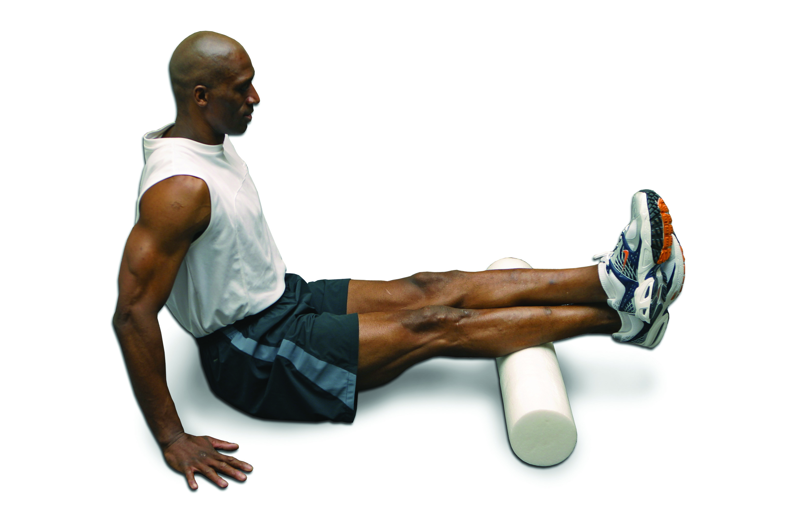 | Hamstring  Beginners- keep one foot on ground  Advanced- lift both feet off ground and cross legs  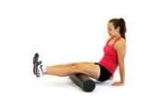 |  | Quadriceps  Beginners- keep one foot on ground  Advanced- lift both feet off ground and cross legs  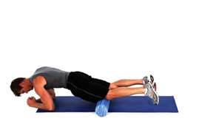 |  |  | Inner Thigh  Beginners- allow opposite knee to rest on floor  Advance- keep opposite knee off floor  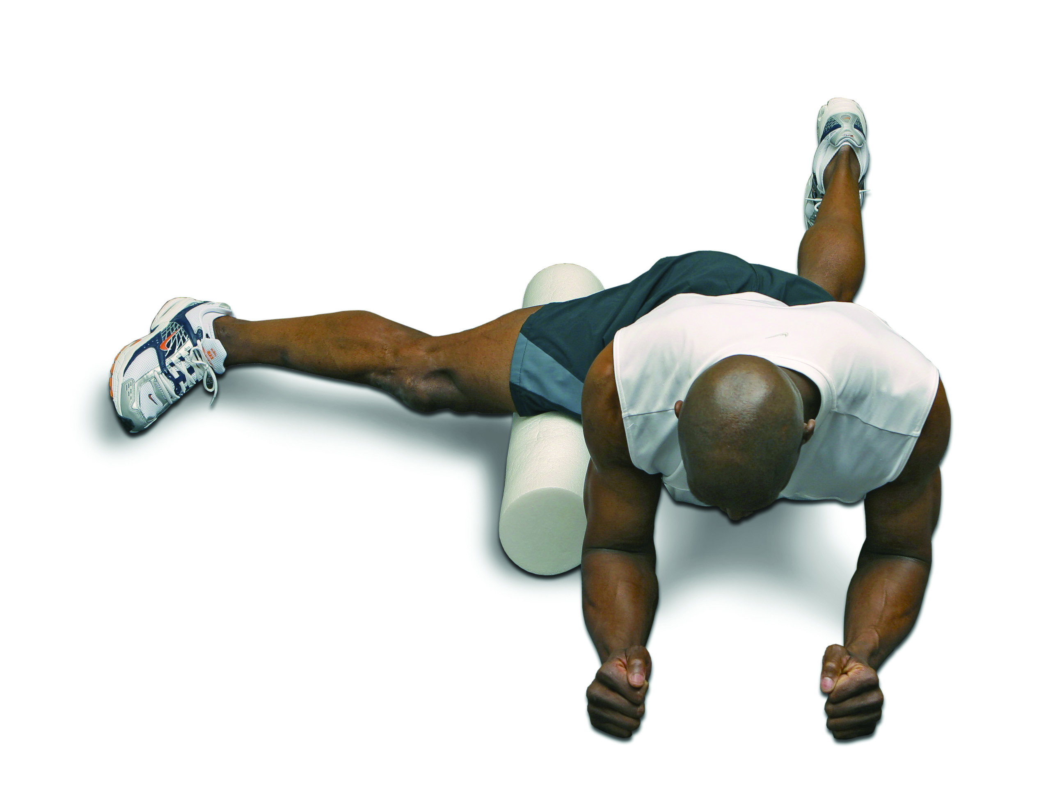
Hip Flexor/IT Band  It’s important to relax during this stretch. It may be tender.  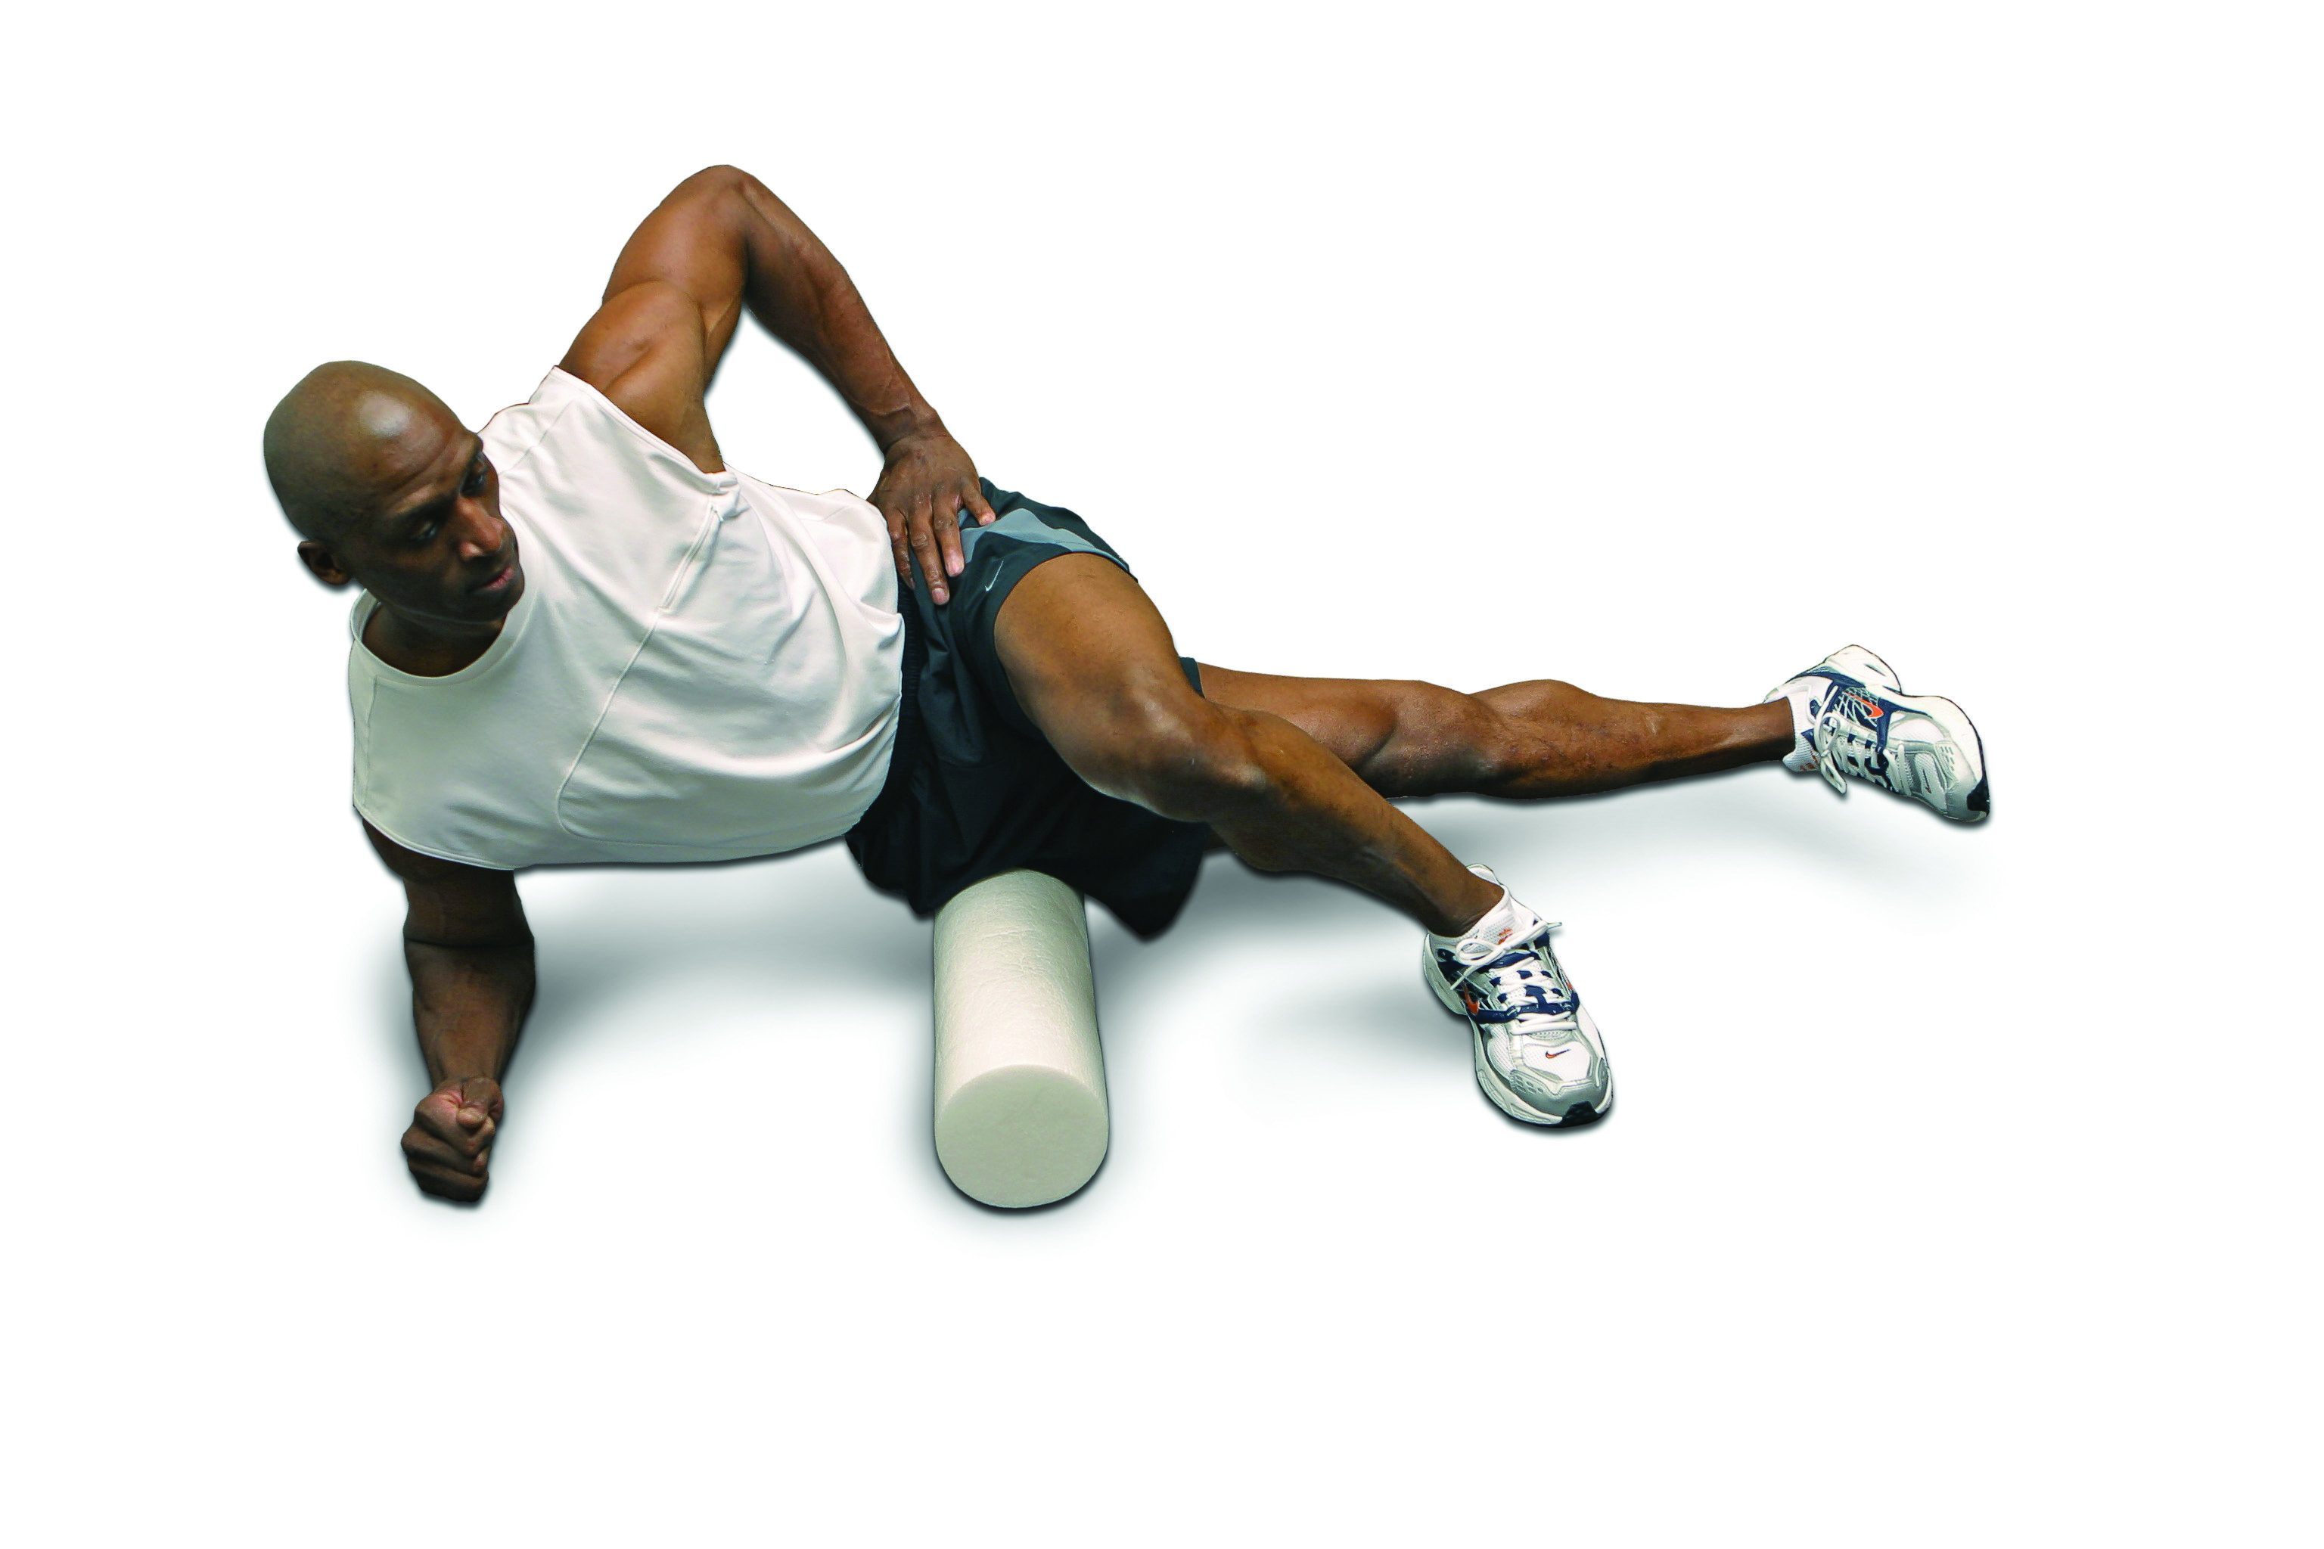 | Glutes  One side should be on the foam roller at a time  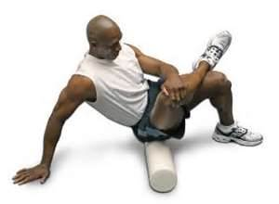 |  | Latissimus Dorsi  Be sure to point the thumb straight up towards the ceiling  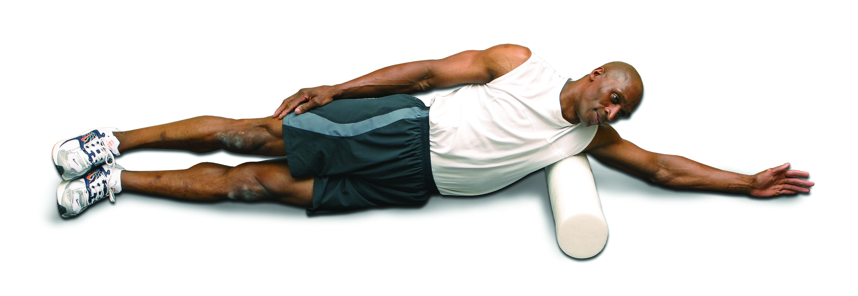 |  |  | Lower Back  Start slowly and relax your shoulders to the ground.  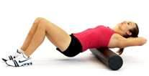

Lab #4
Resistance Training
Perform all exercises for 1 set, 12 reps at a slow tempo

Total Body | Chest | Back | Shoulders | Legs
Squat to Row  Progressions:  - Alternating arms  - One arm  - One arm w/trunk rotation  - On one leg  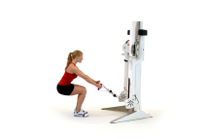  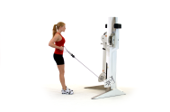 | Push-up  Progressions:  - Stagger hand position  - Place one hand on medicine ball  - Feet on stability ball  - Hands on stability ball  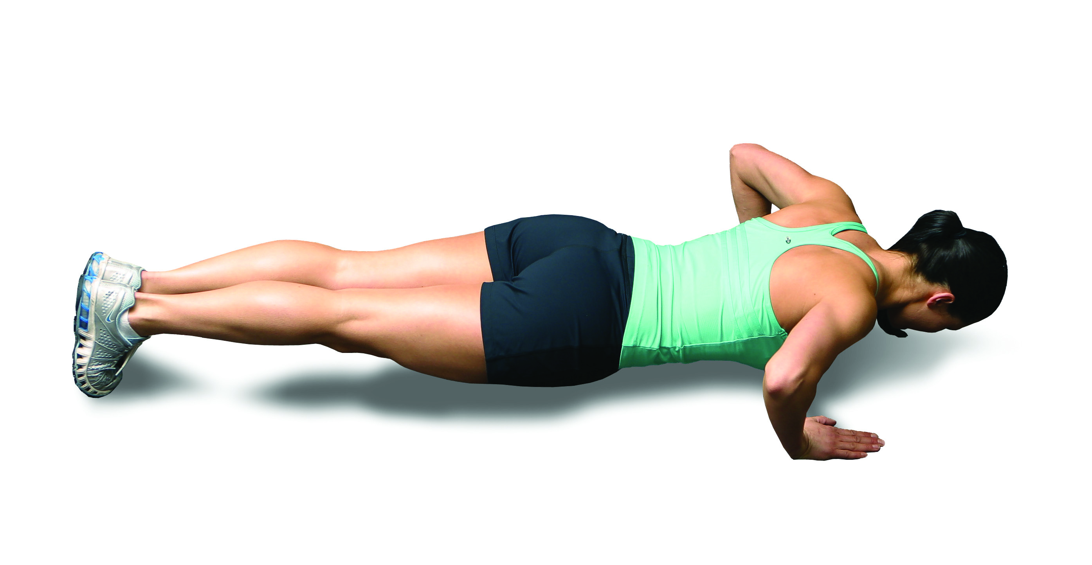 | Floor Cobra  Be sure to retract and depress scapula and point thumb in the air  Progressions:  - Alternating arms  - One arm  - One arm w/trunk rotation  - On stability ball  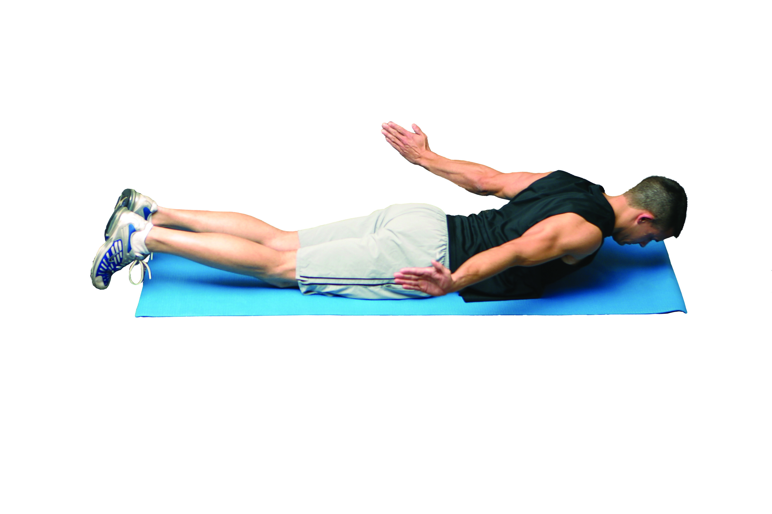 | Cable Abduction  Progressions:  - Alternating arms  - One arm  - One arm w/rotation  - On one leg  (Place middle of tubing under feet)  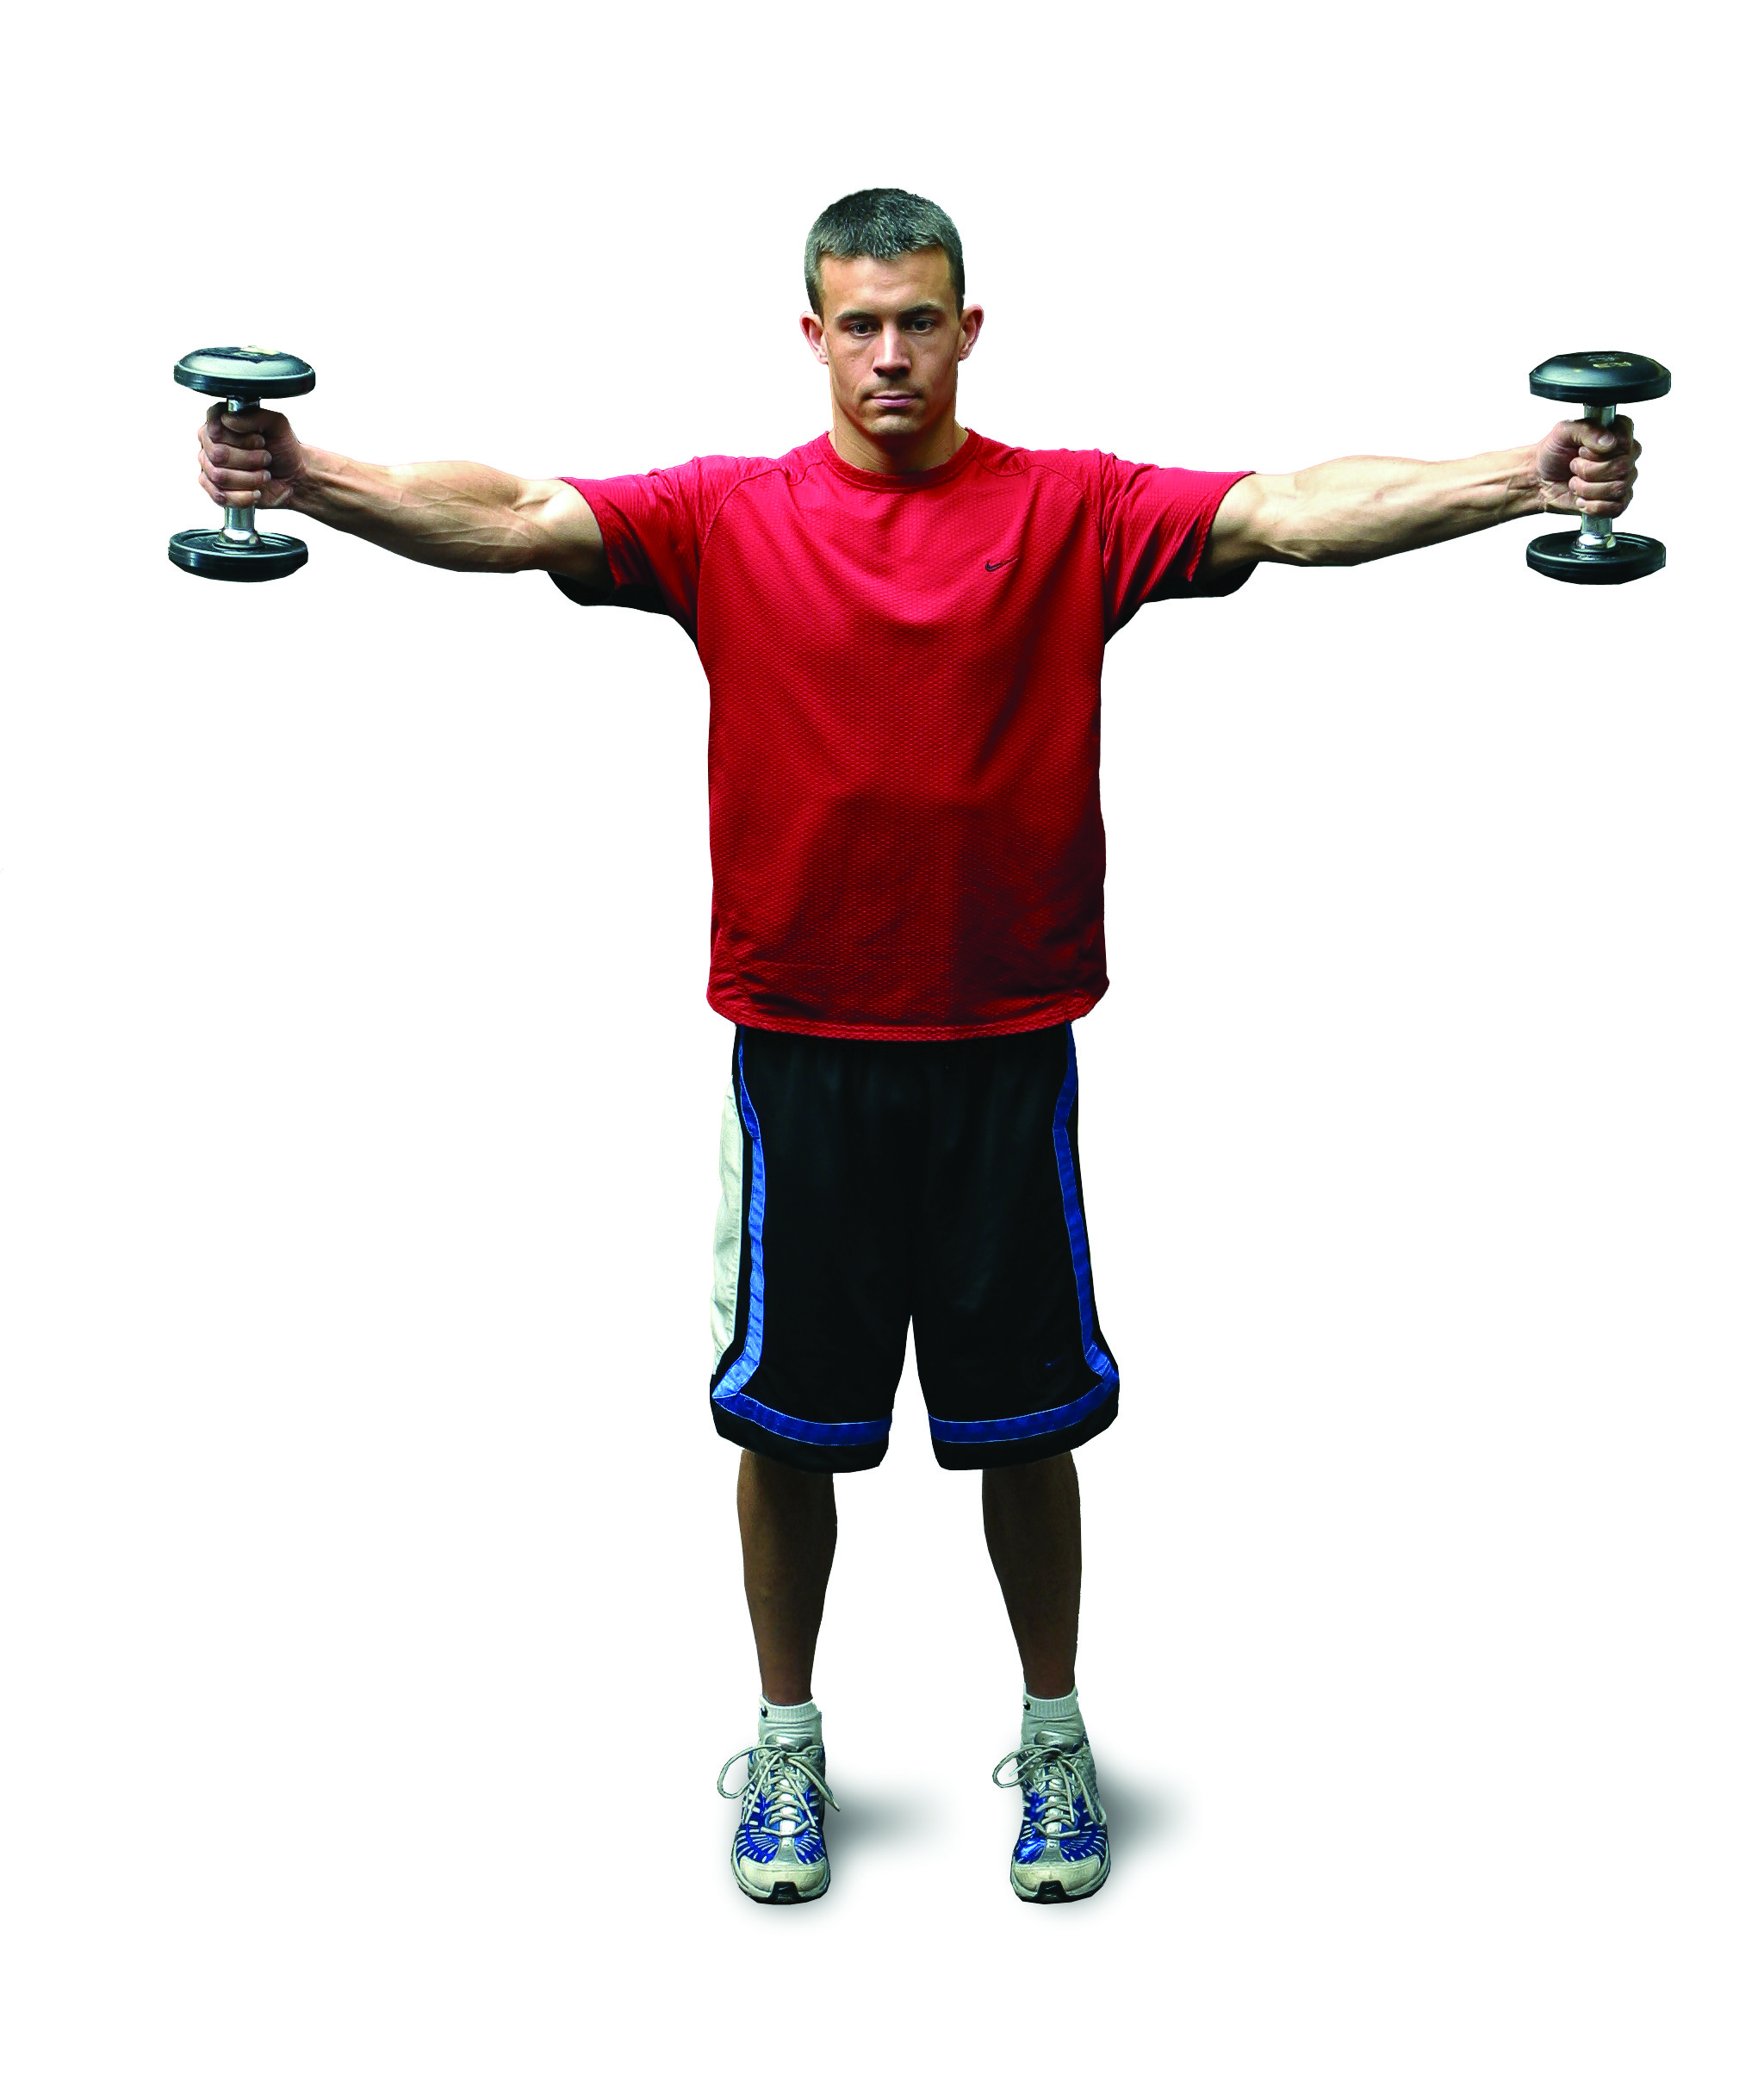 | Single-Leg Squat  Squat as far as can be safely controlled  Progressions:  - Add resistance  - Add balance modality such as ½ foam roll, airex pad or dyna disc.  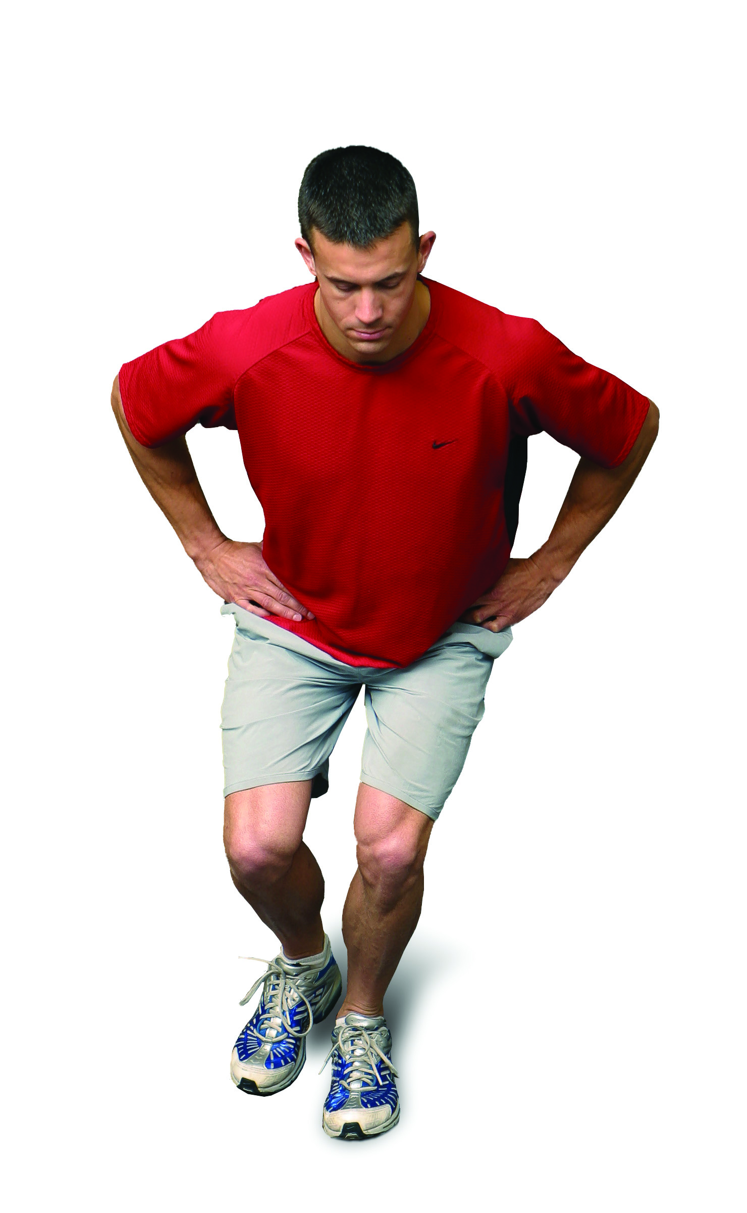
Squat Curl to Press  Progressions:  - Alternating arms  - One arm  - Stand on balance modality On one leg  (Place middle of tubing under feet)  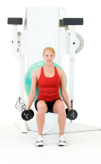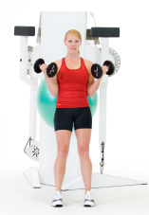  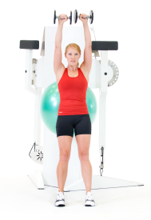 | Standing Cable Press  Progressions:  - Alternating arms  - One arm  - One arm w/trunk rotation  - On one leg  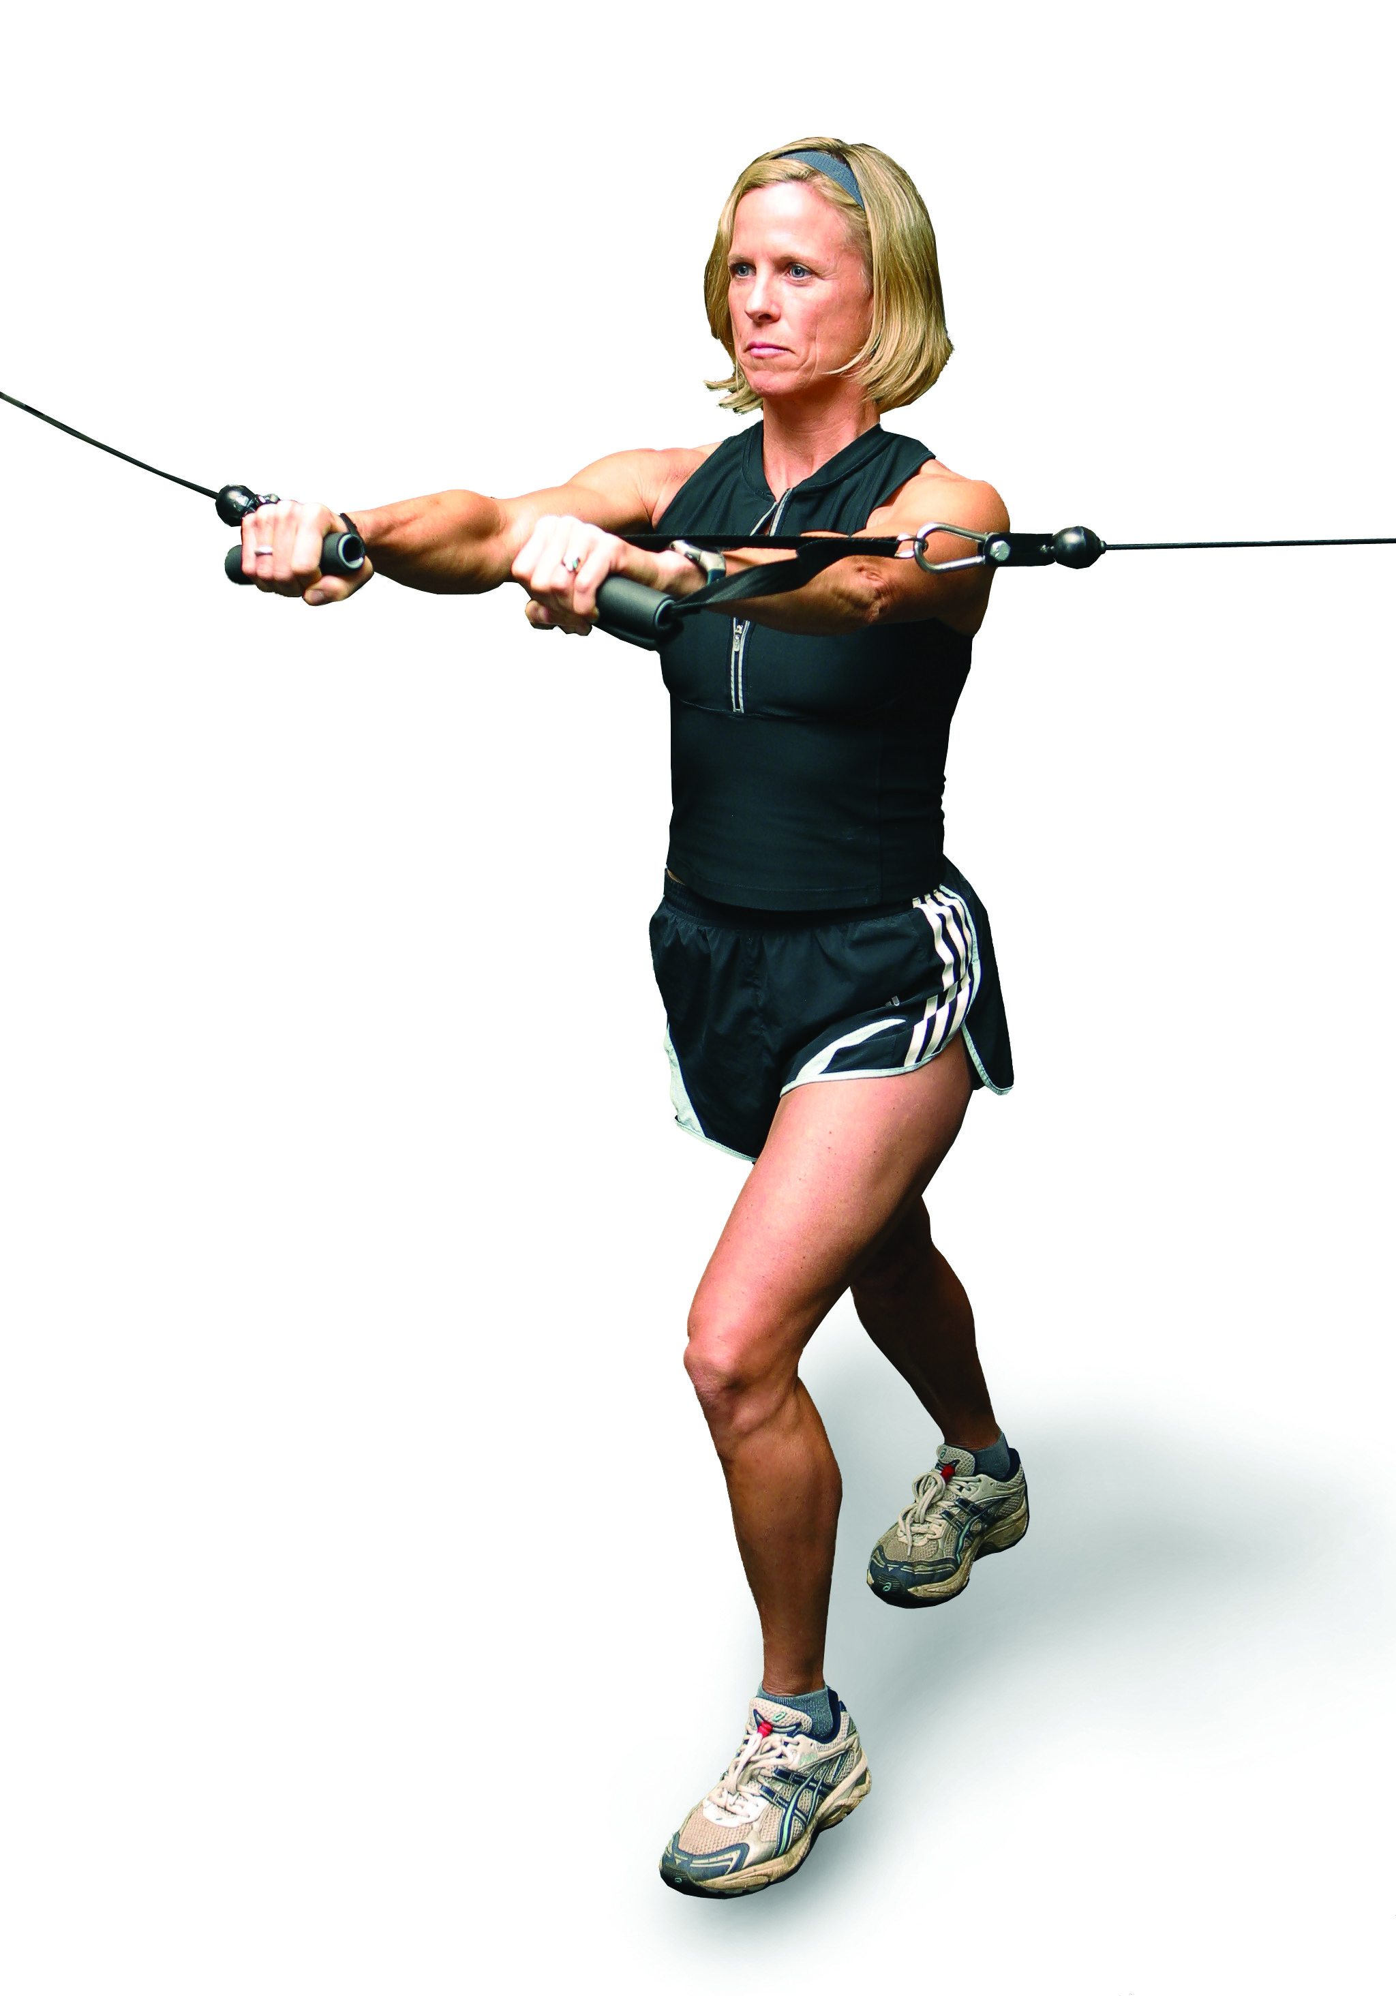 | Cable Row  Progressions:  - Alternating arms  - One arm  - One arm w/trunk rotation  - On one leg  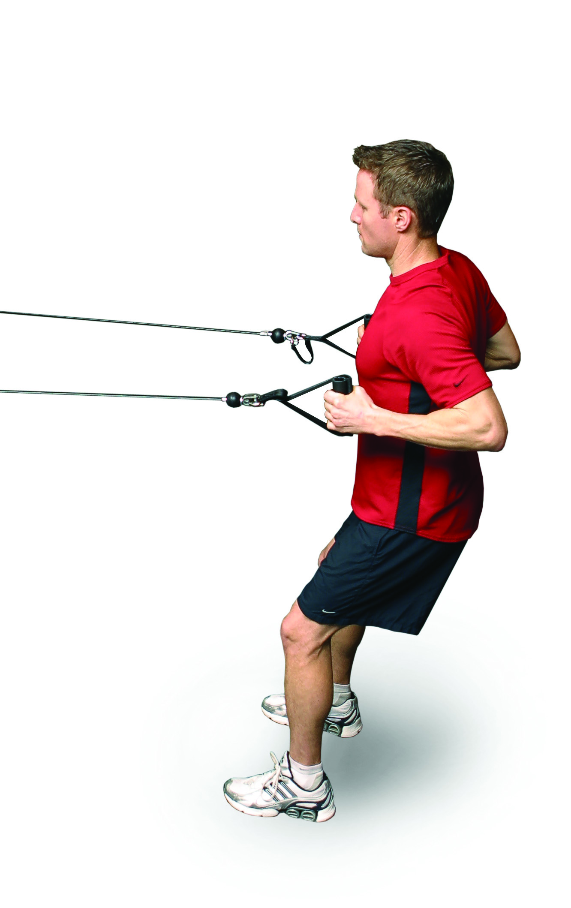 | Standing Cable Shoulder Press  Progressions:  - Alternating arms  - One arm  - One arm w/trunk rotation  - On one leg  (Place middle of tubing under feet)  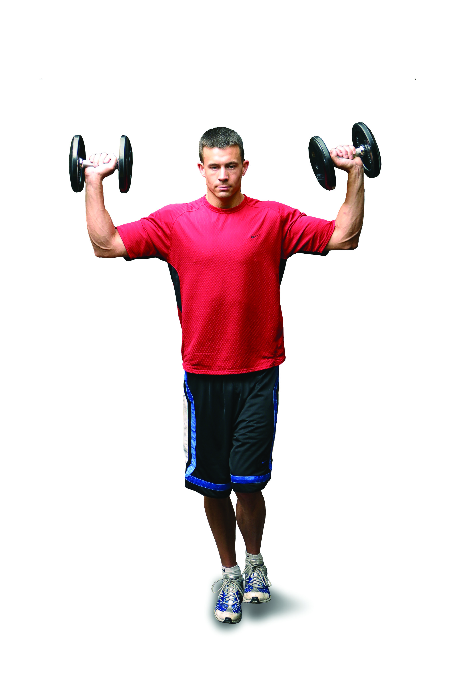 | Lunges  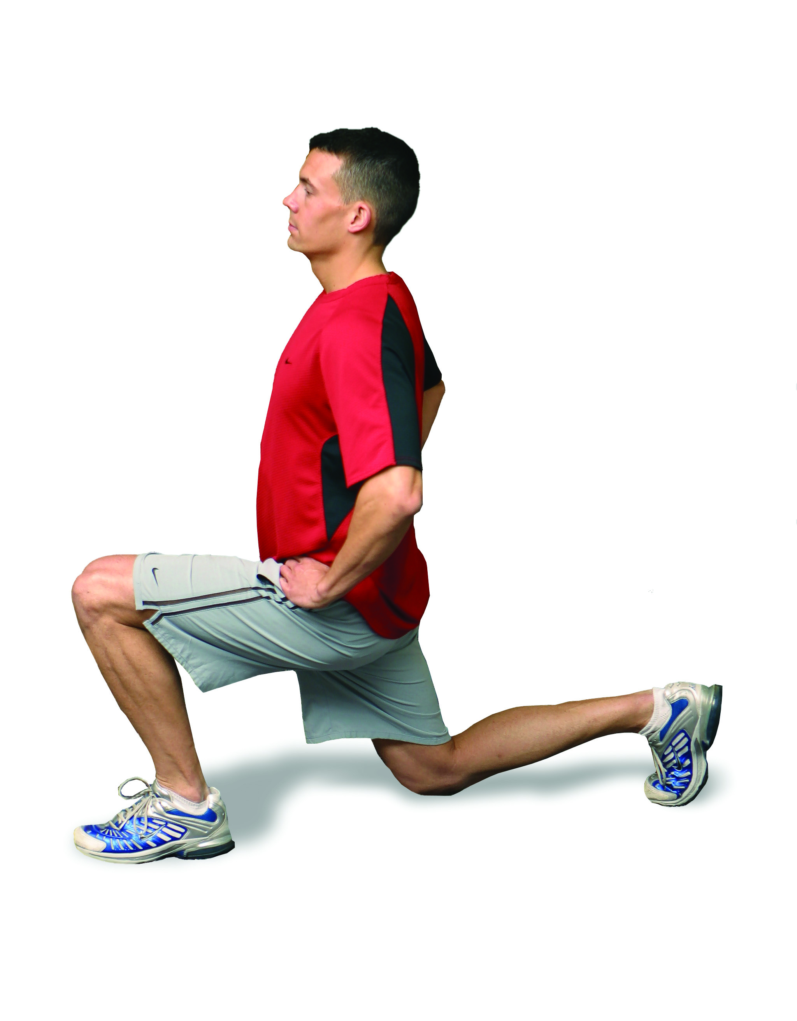  Progressions:  - Side to side lunges  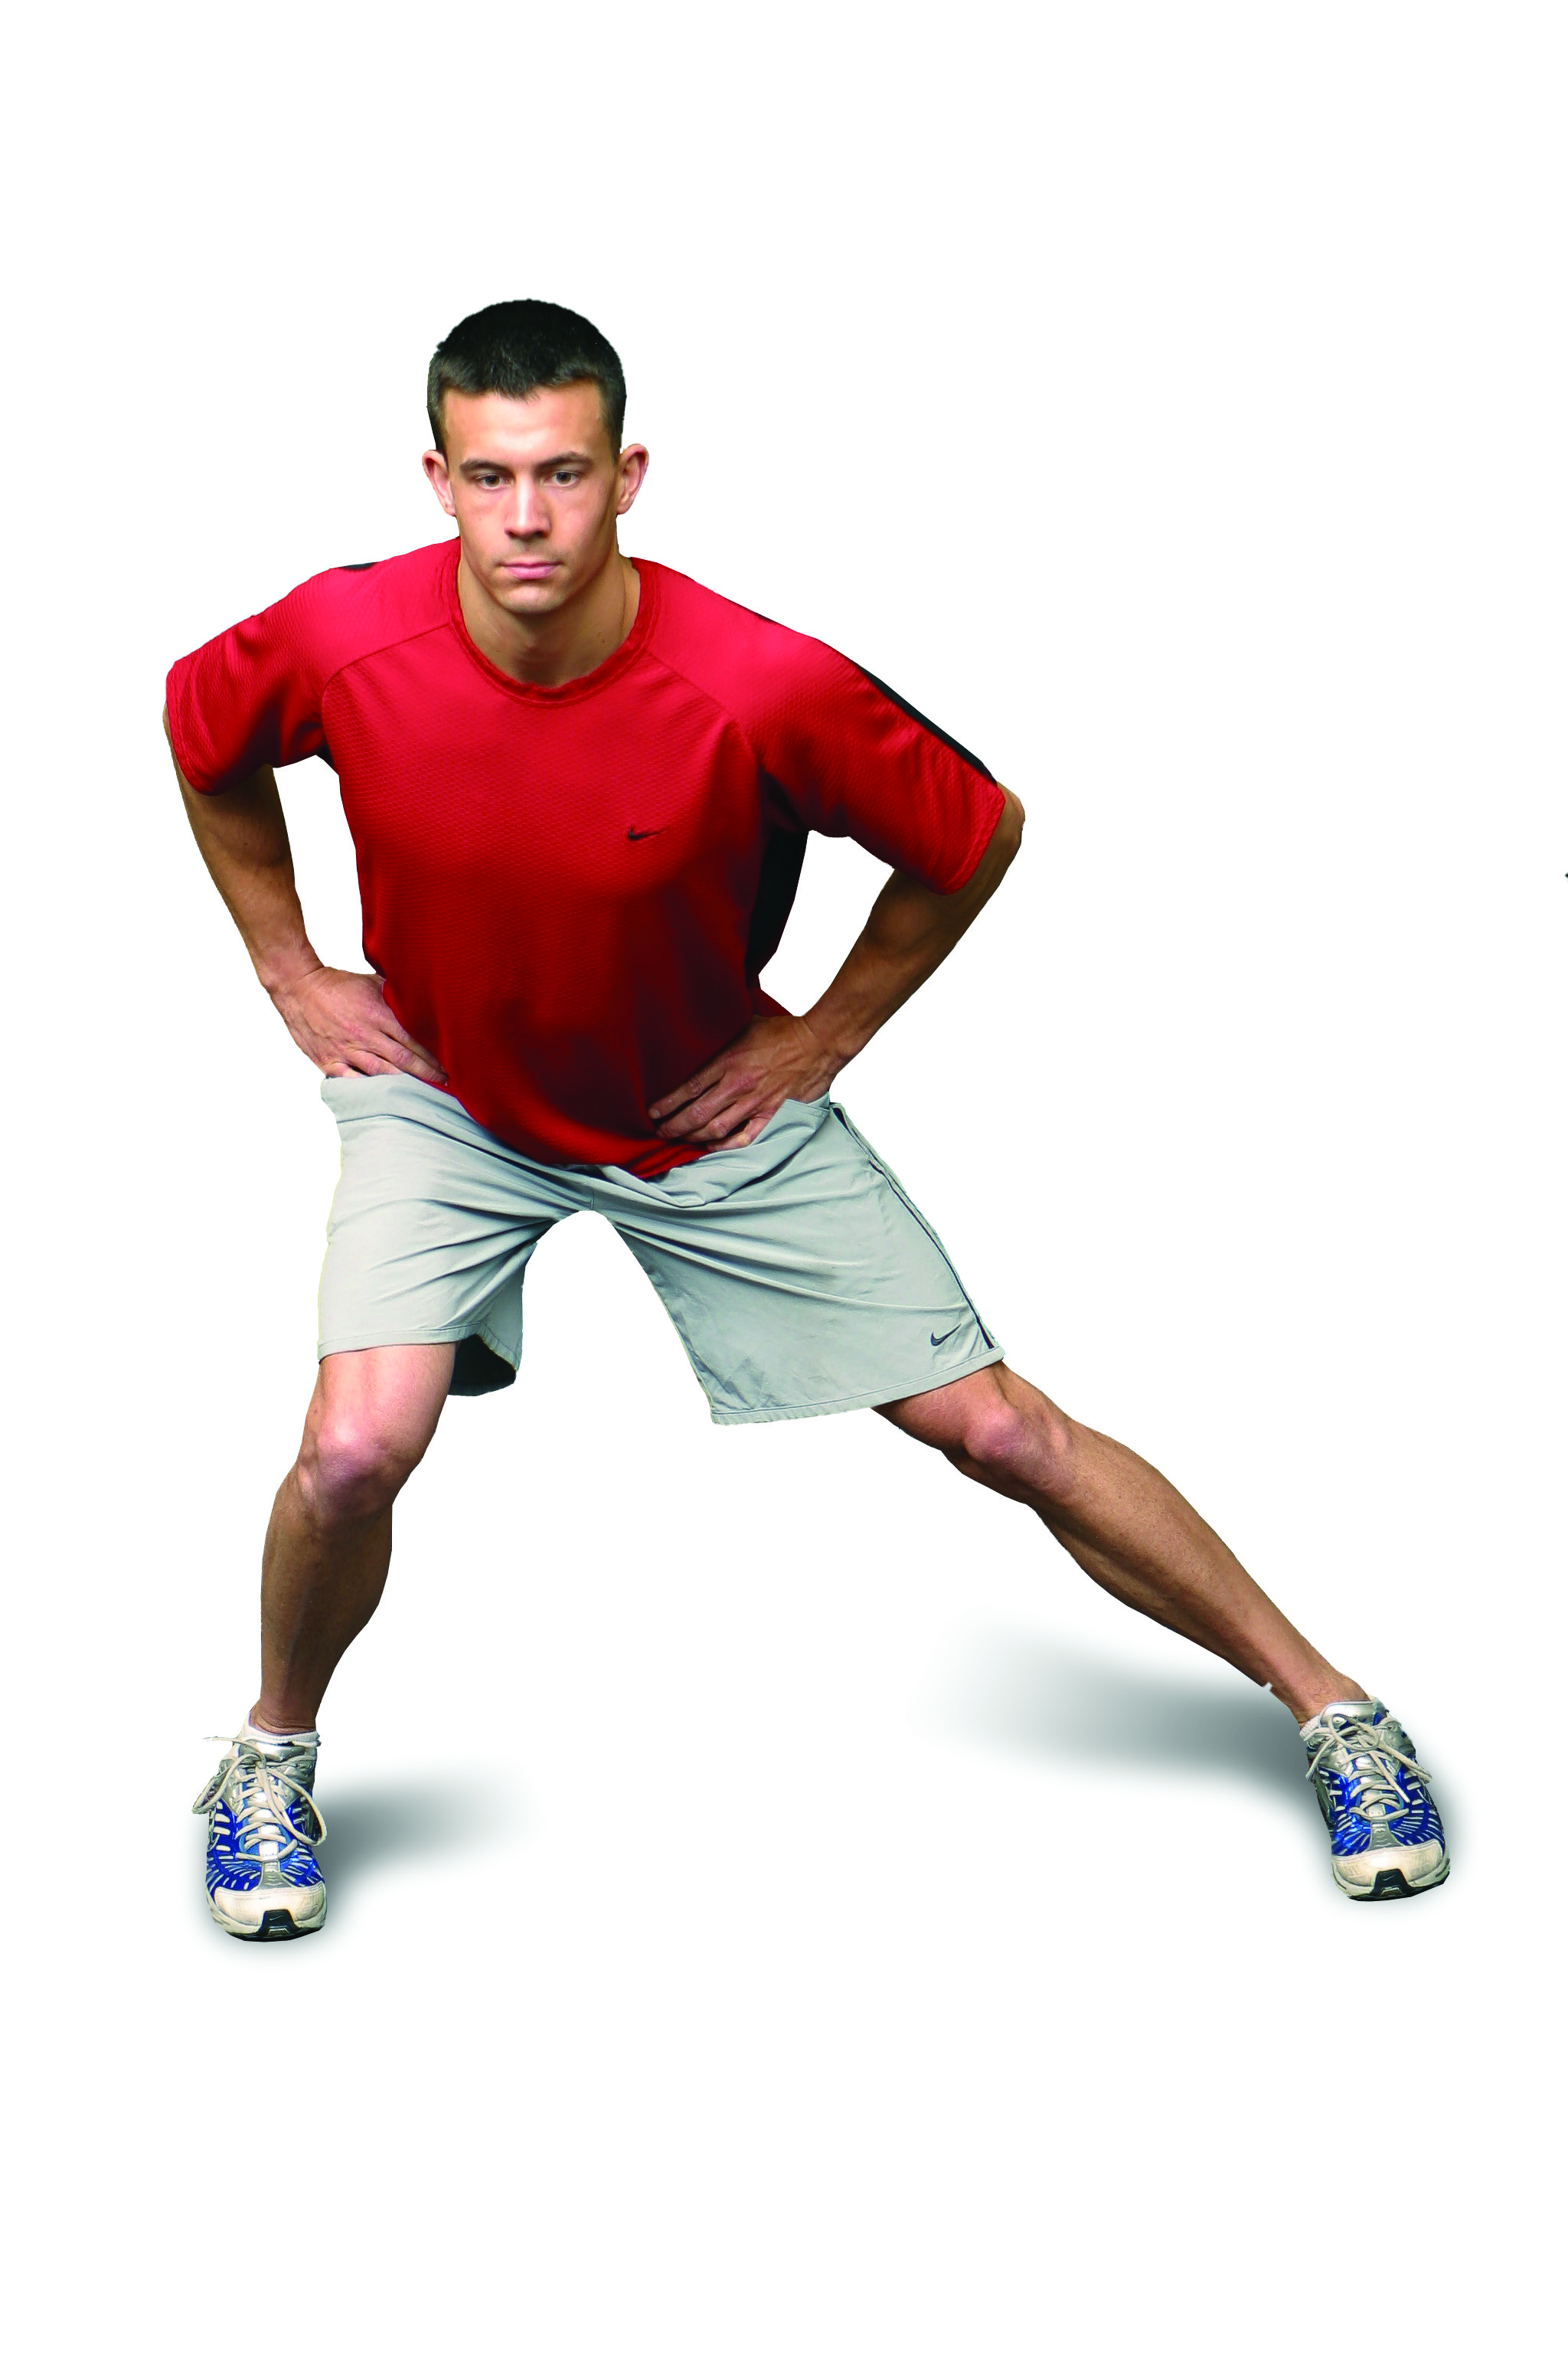  - Turning lunges  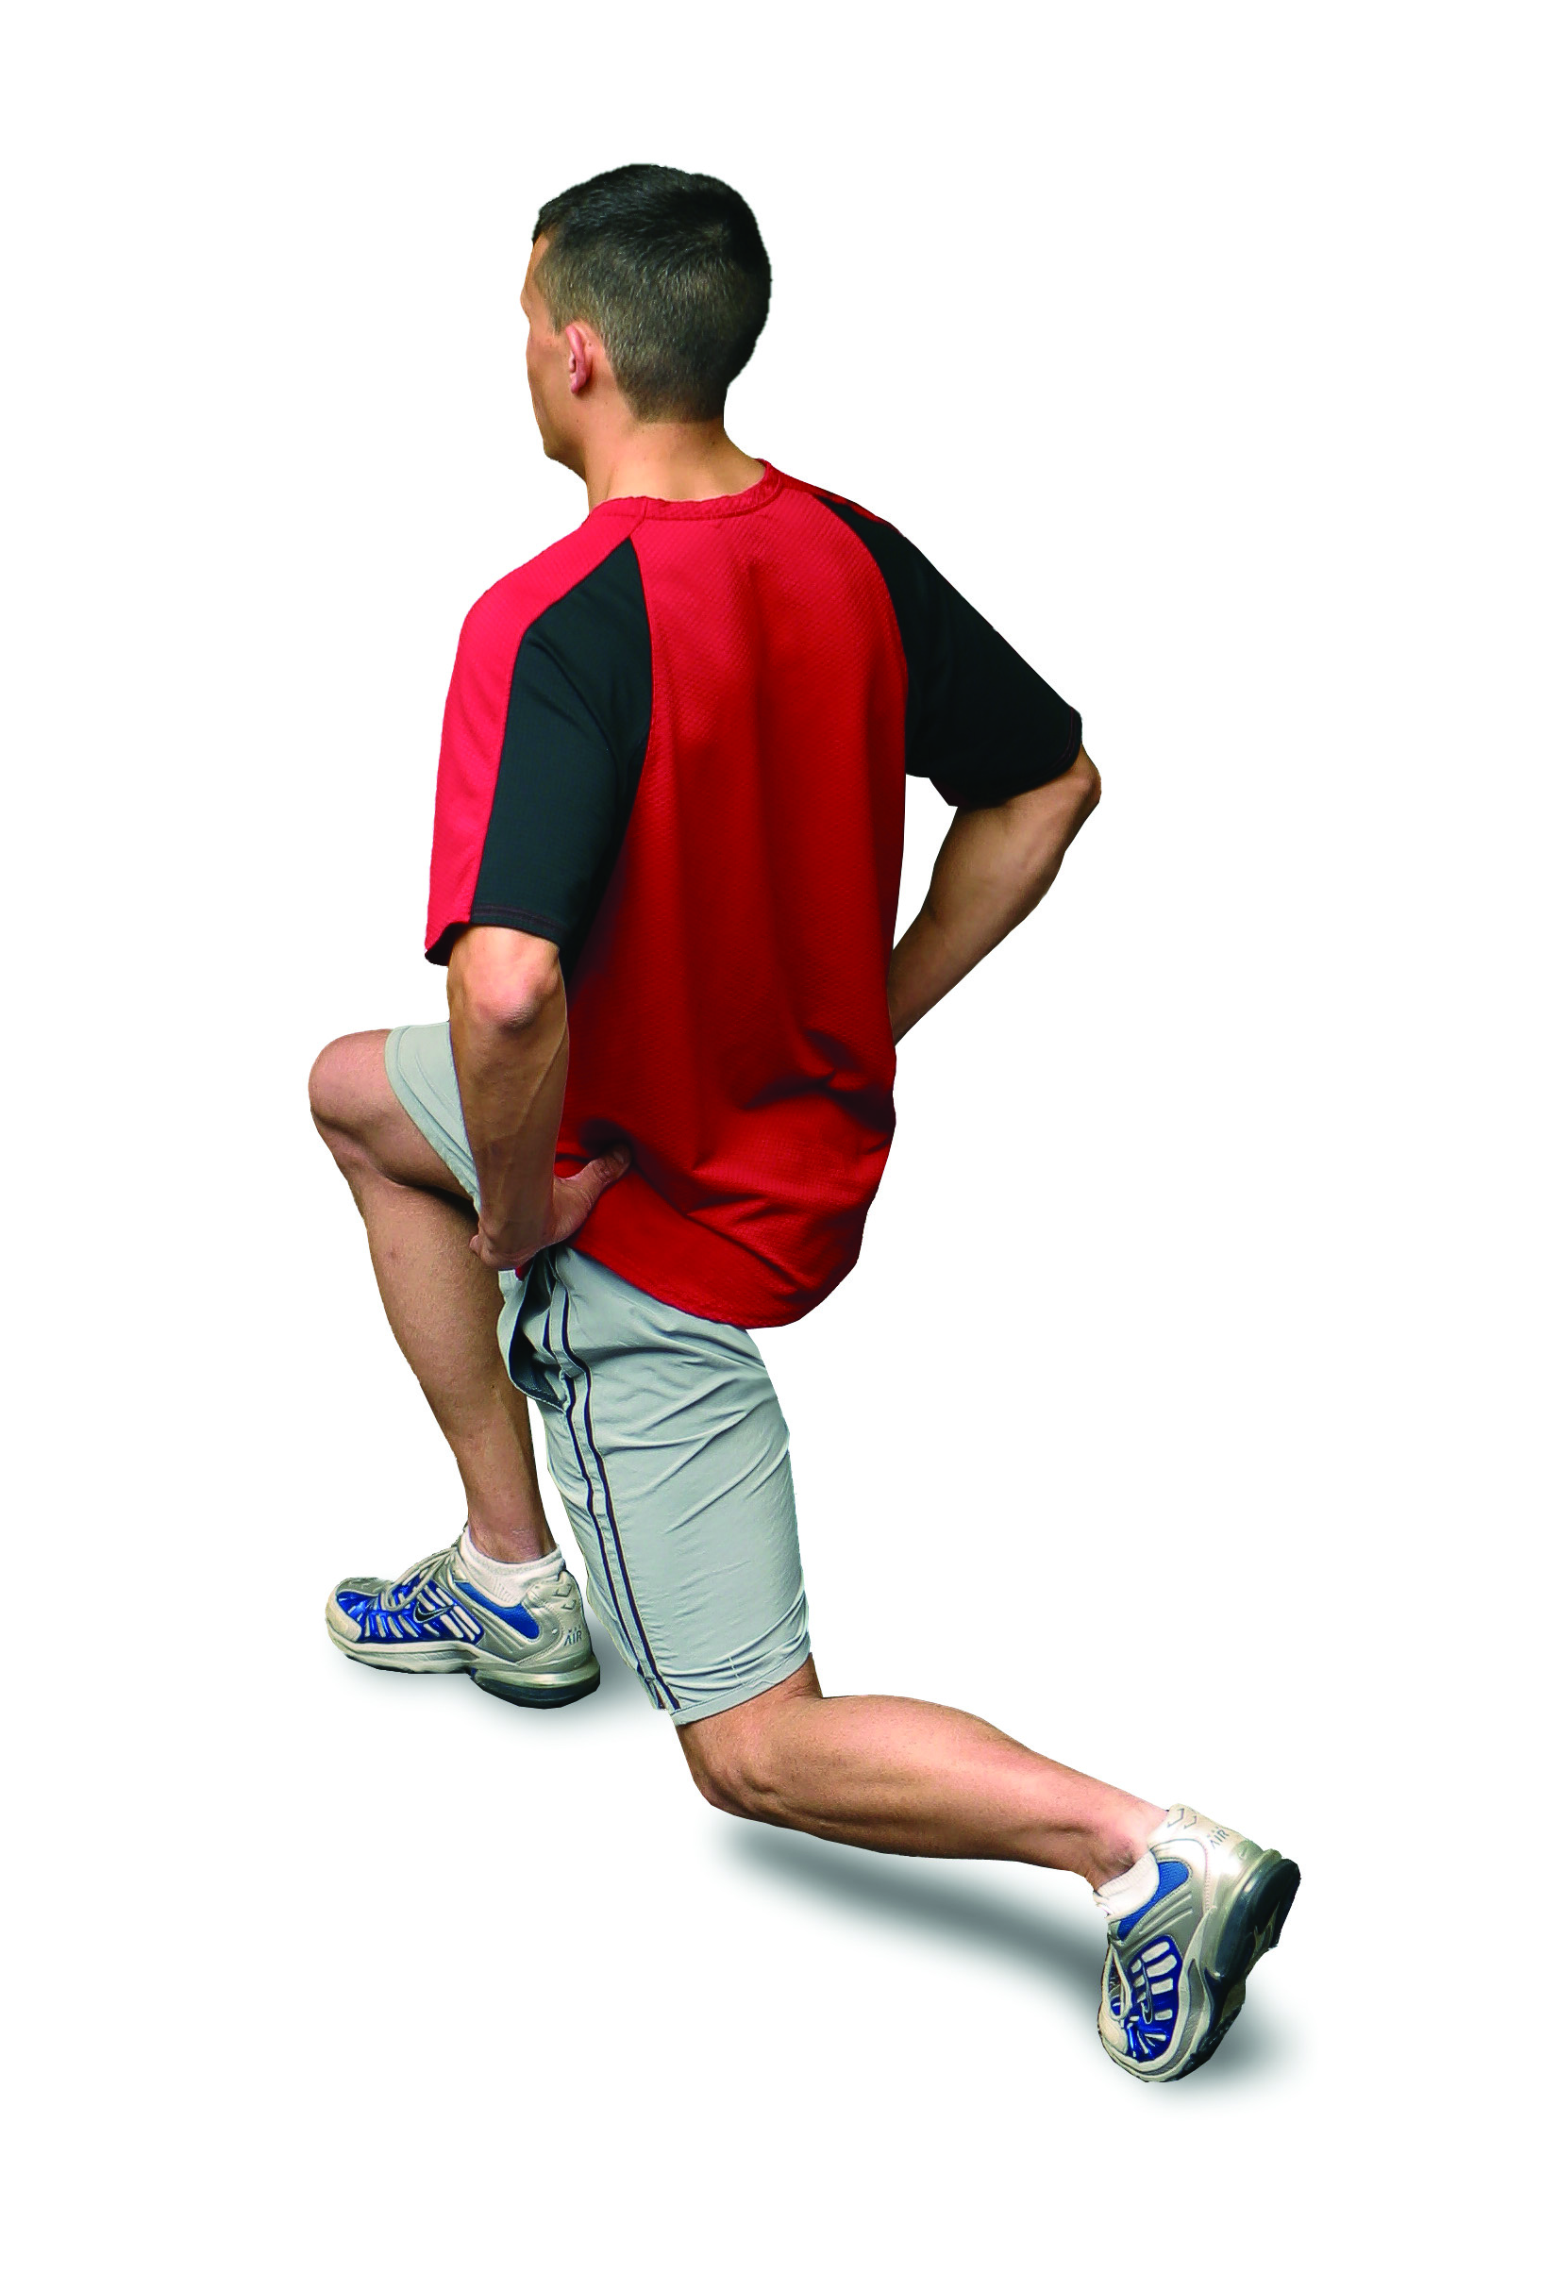  - Add balance modality  - Add resistance

