Lab #3 - Stabilization

Below are the instructions for the exercises you will be performing.
Core Stabilization  Perform 12-20 repetitions |  | Balance Stabilization  Perform 12-20 repetitions
Floor Bridge  Progressions:  - Contract Transversus Abdominus first  - Perform floor bridge  - Straighten one leg with bridge | Prone Iso-Ab  Progressions:  - Contract Transversus Abdominus first  - Perform plank  - Lift 1 leg  - Bring leg to side  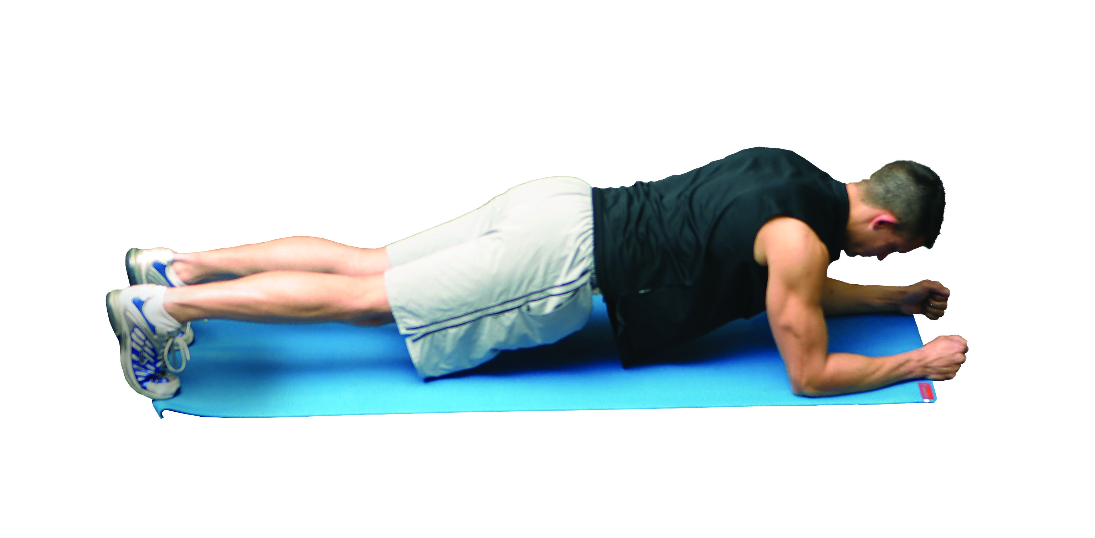 | Single-leg Balance  Progressions:  - Hold for 15 seconds  - 1 eye closed  - 2 eyes closed  - Rotating head  - Cover ears/eyes  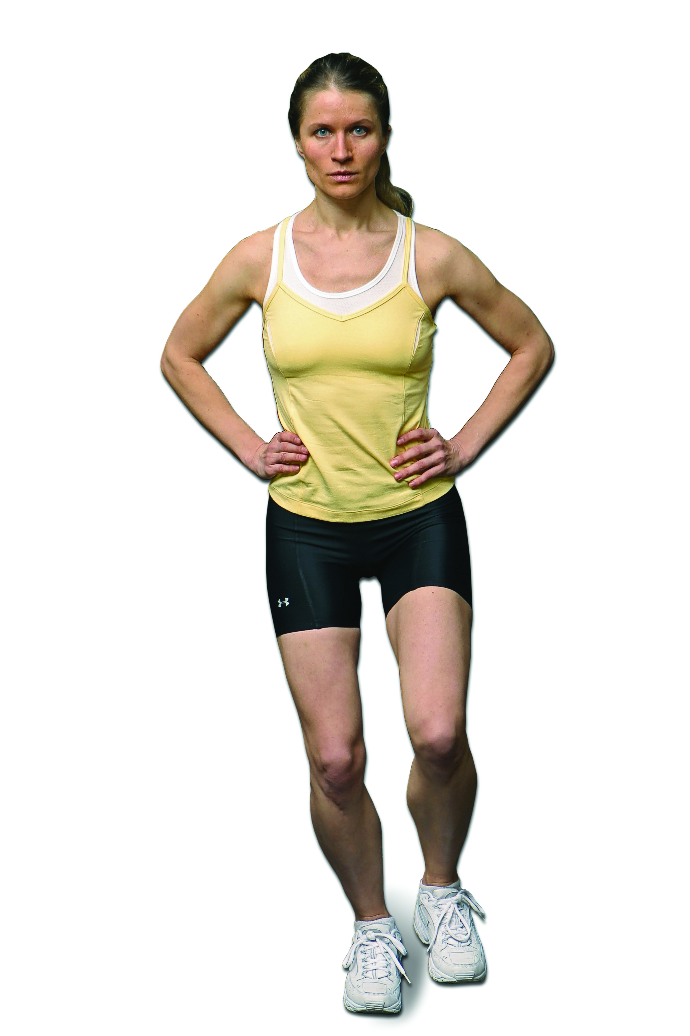 | Single-leg Balance Reach  Progressions:  - Reach to the side  - Turn & reach behind  - Close eyes  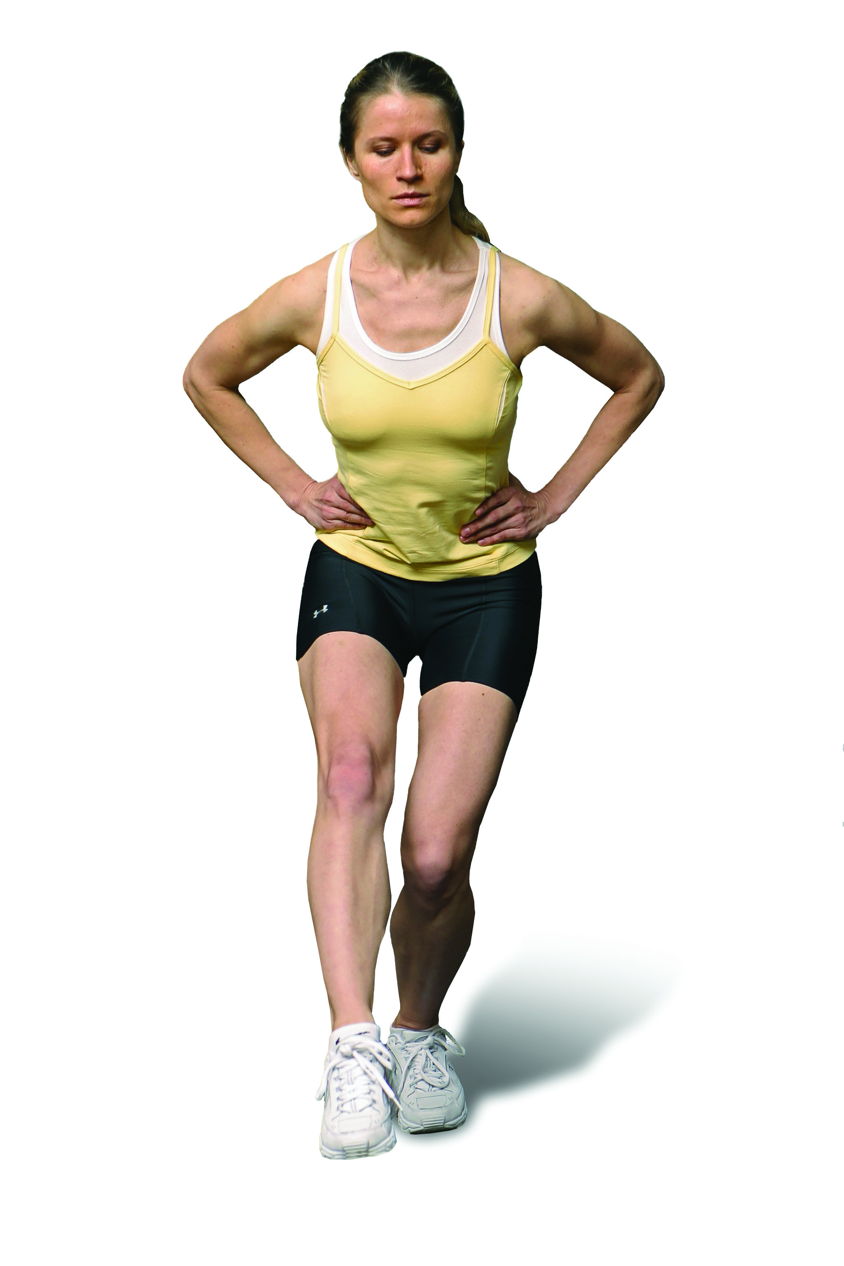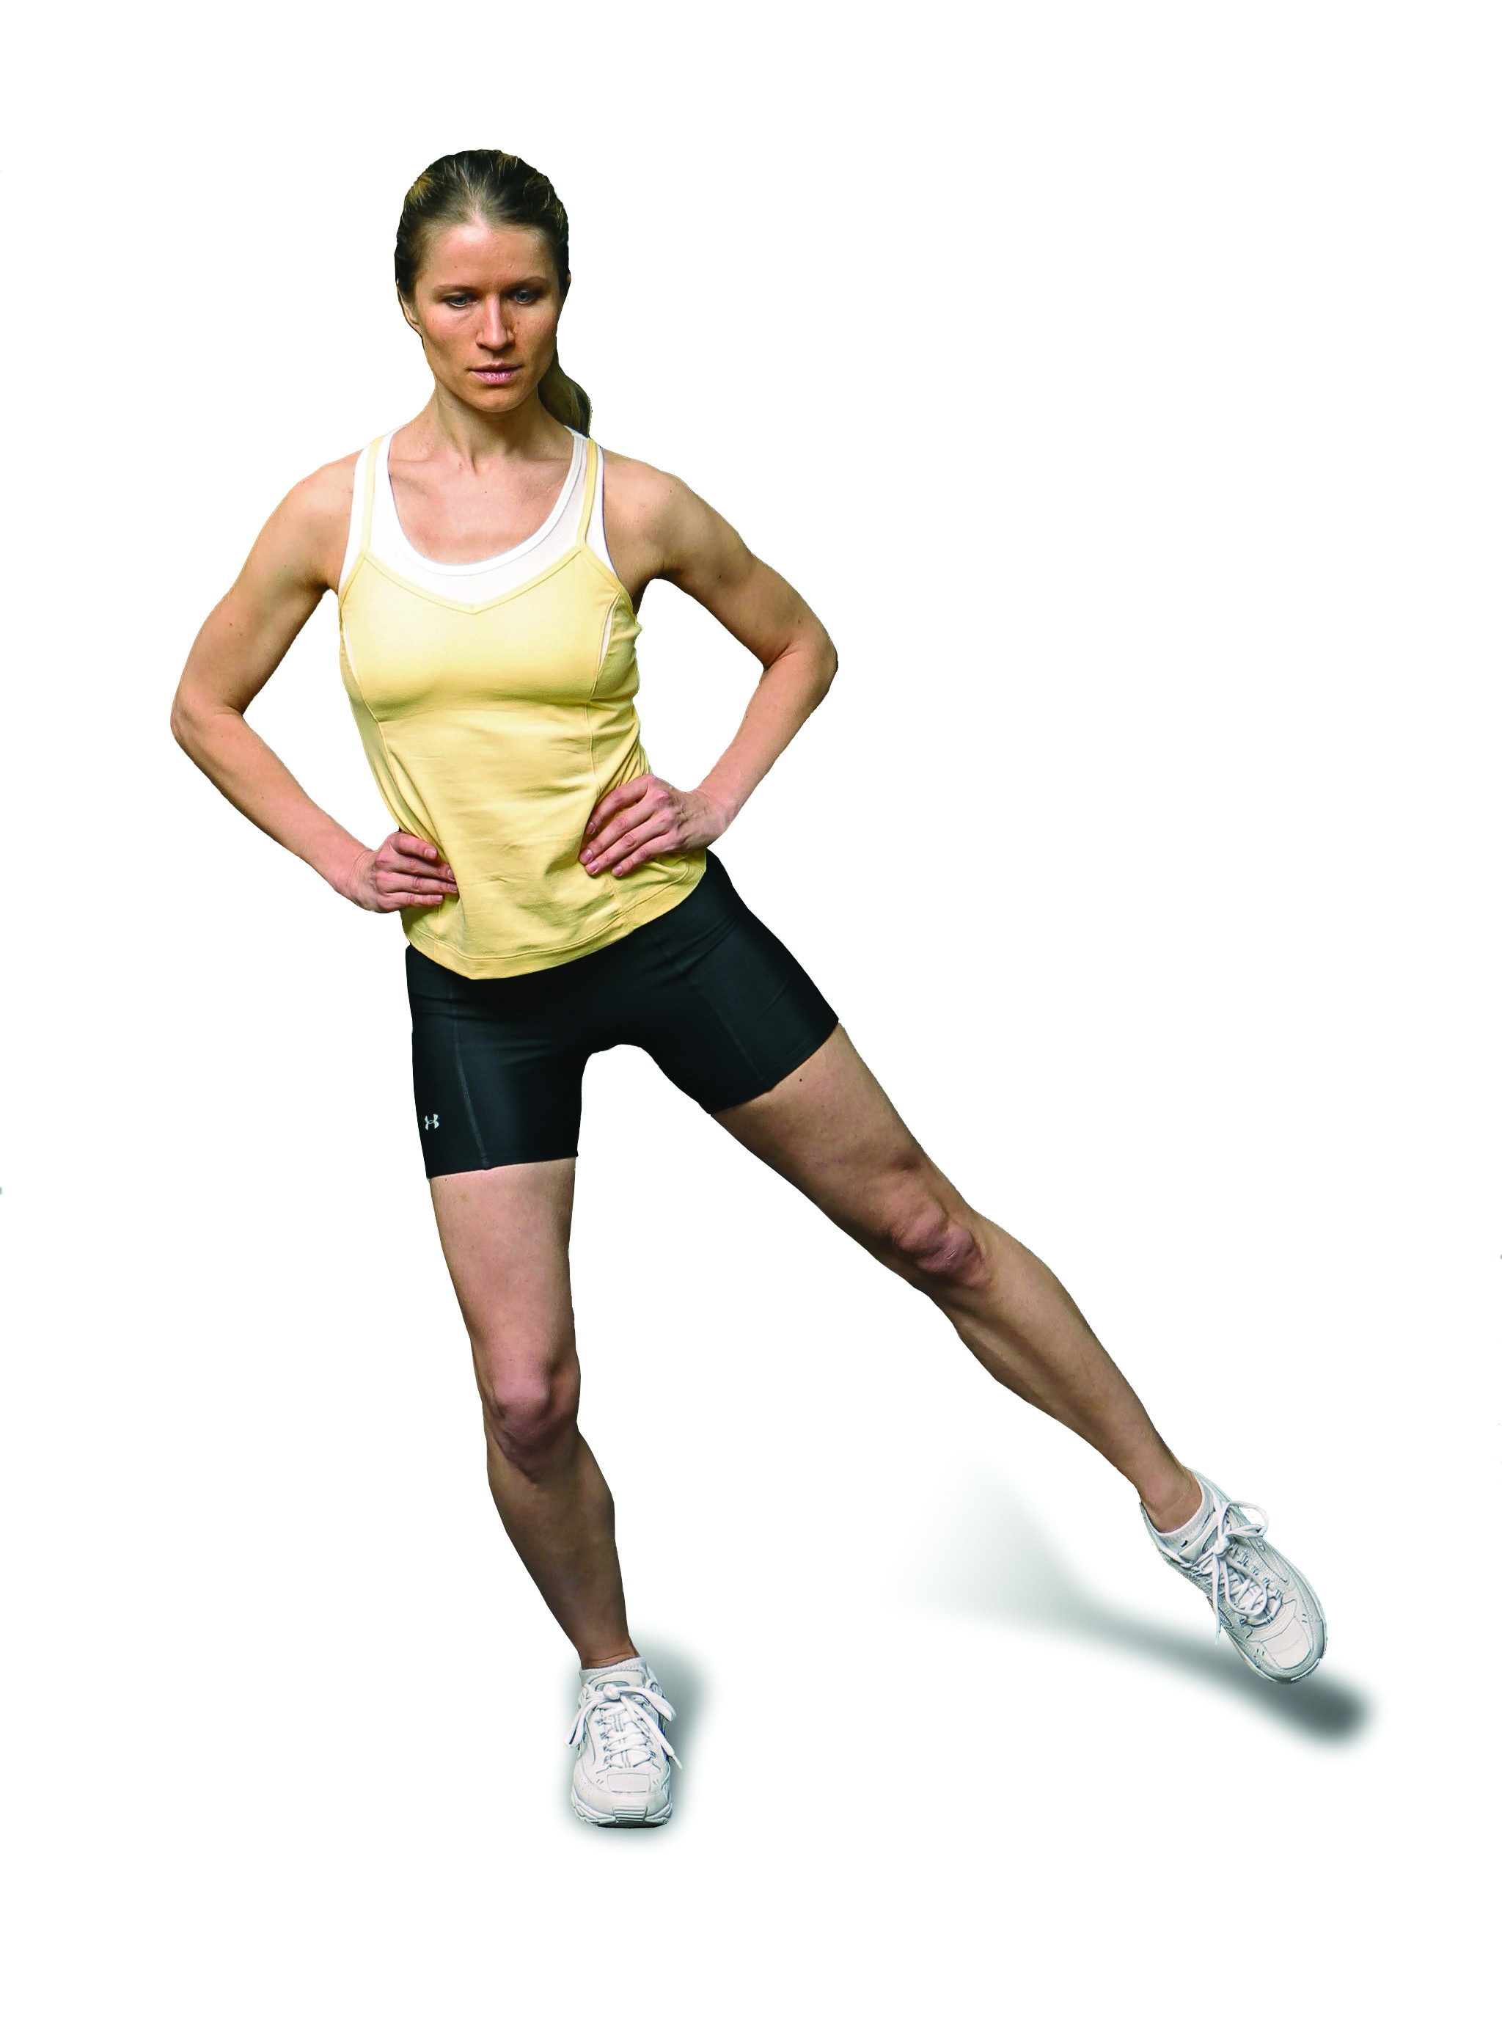  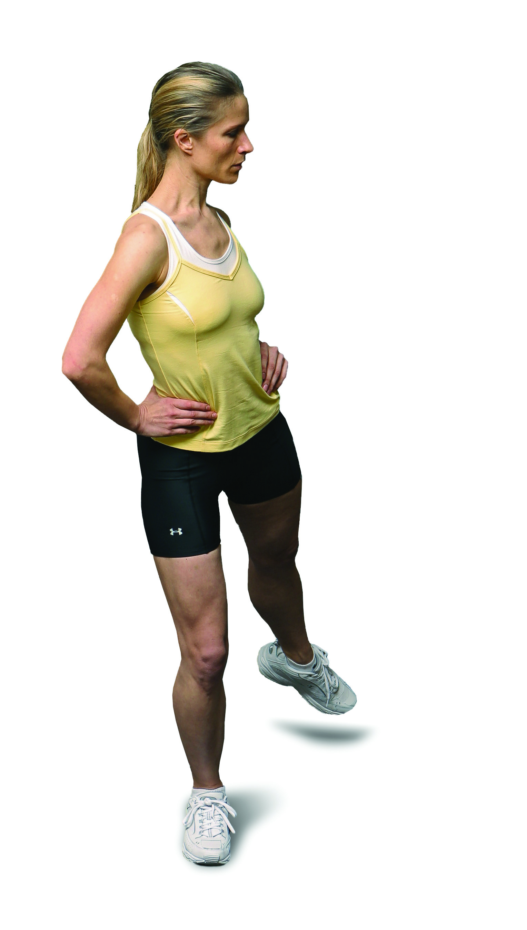
Core Strength  Perform 8-12 repetitions |  | Balance Strength  Perform 8-12 repetitions
Floor Crunch  Progressions:  - Hands behind ears  - Hands overhead  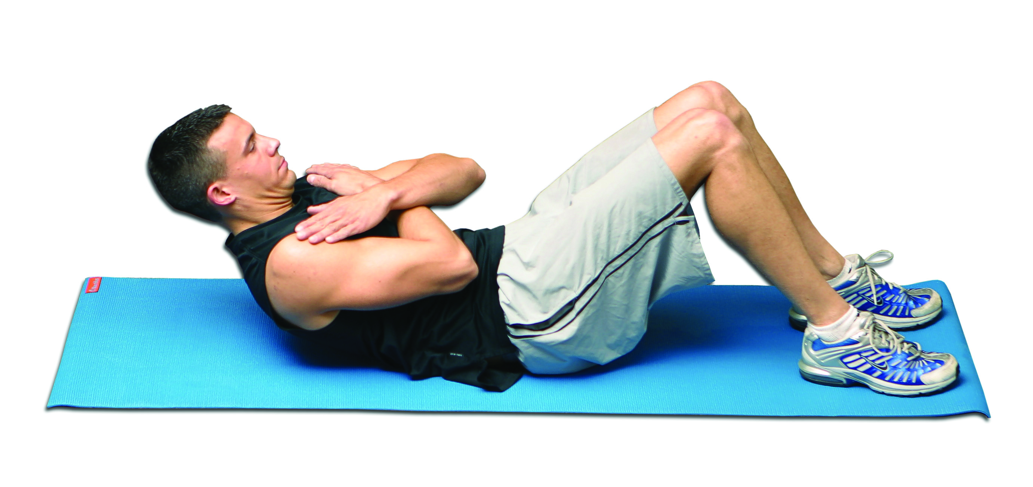 | Trunk Rotation  Progressions:  - Change modality  - Add unstable surface  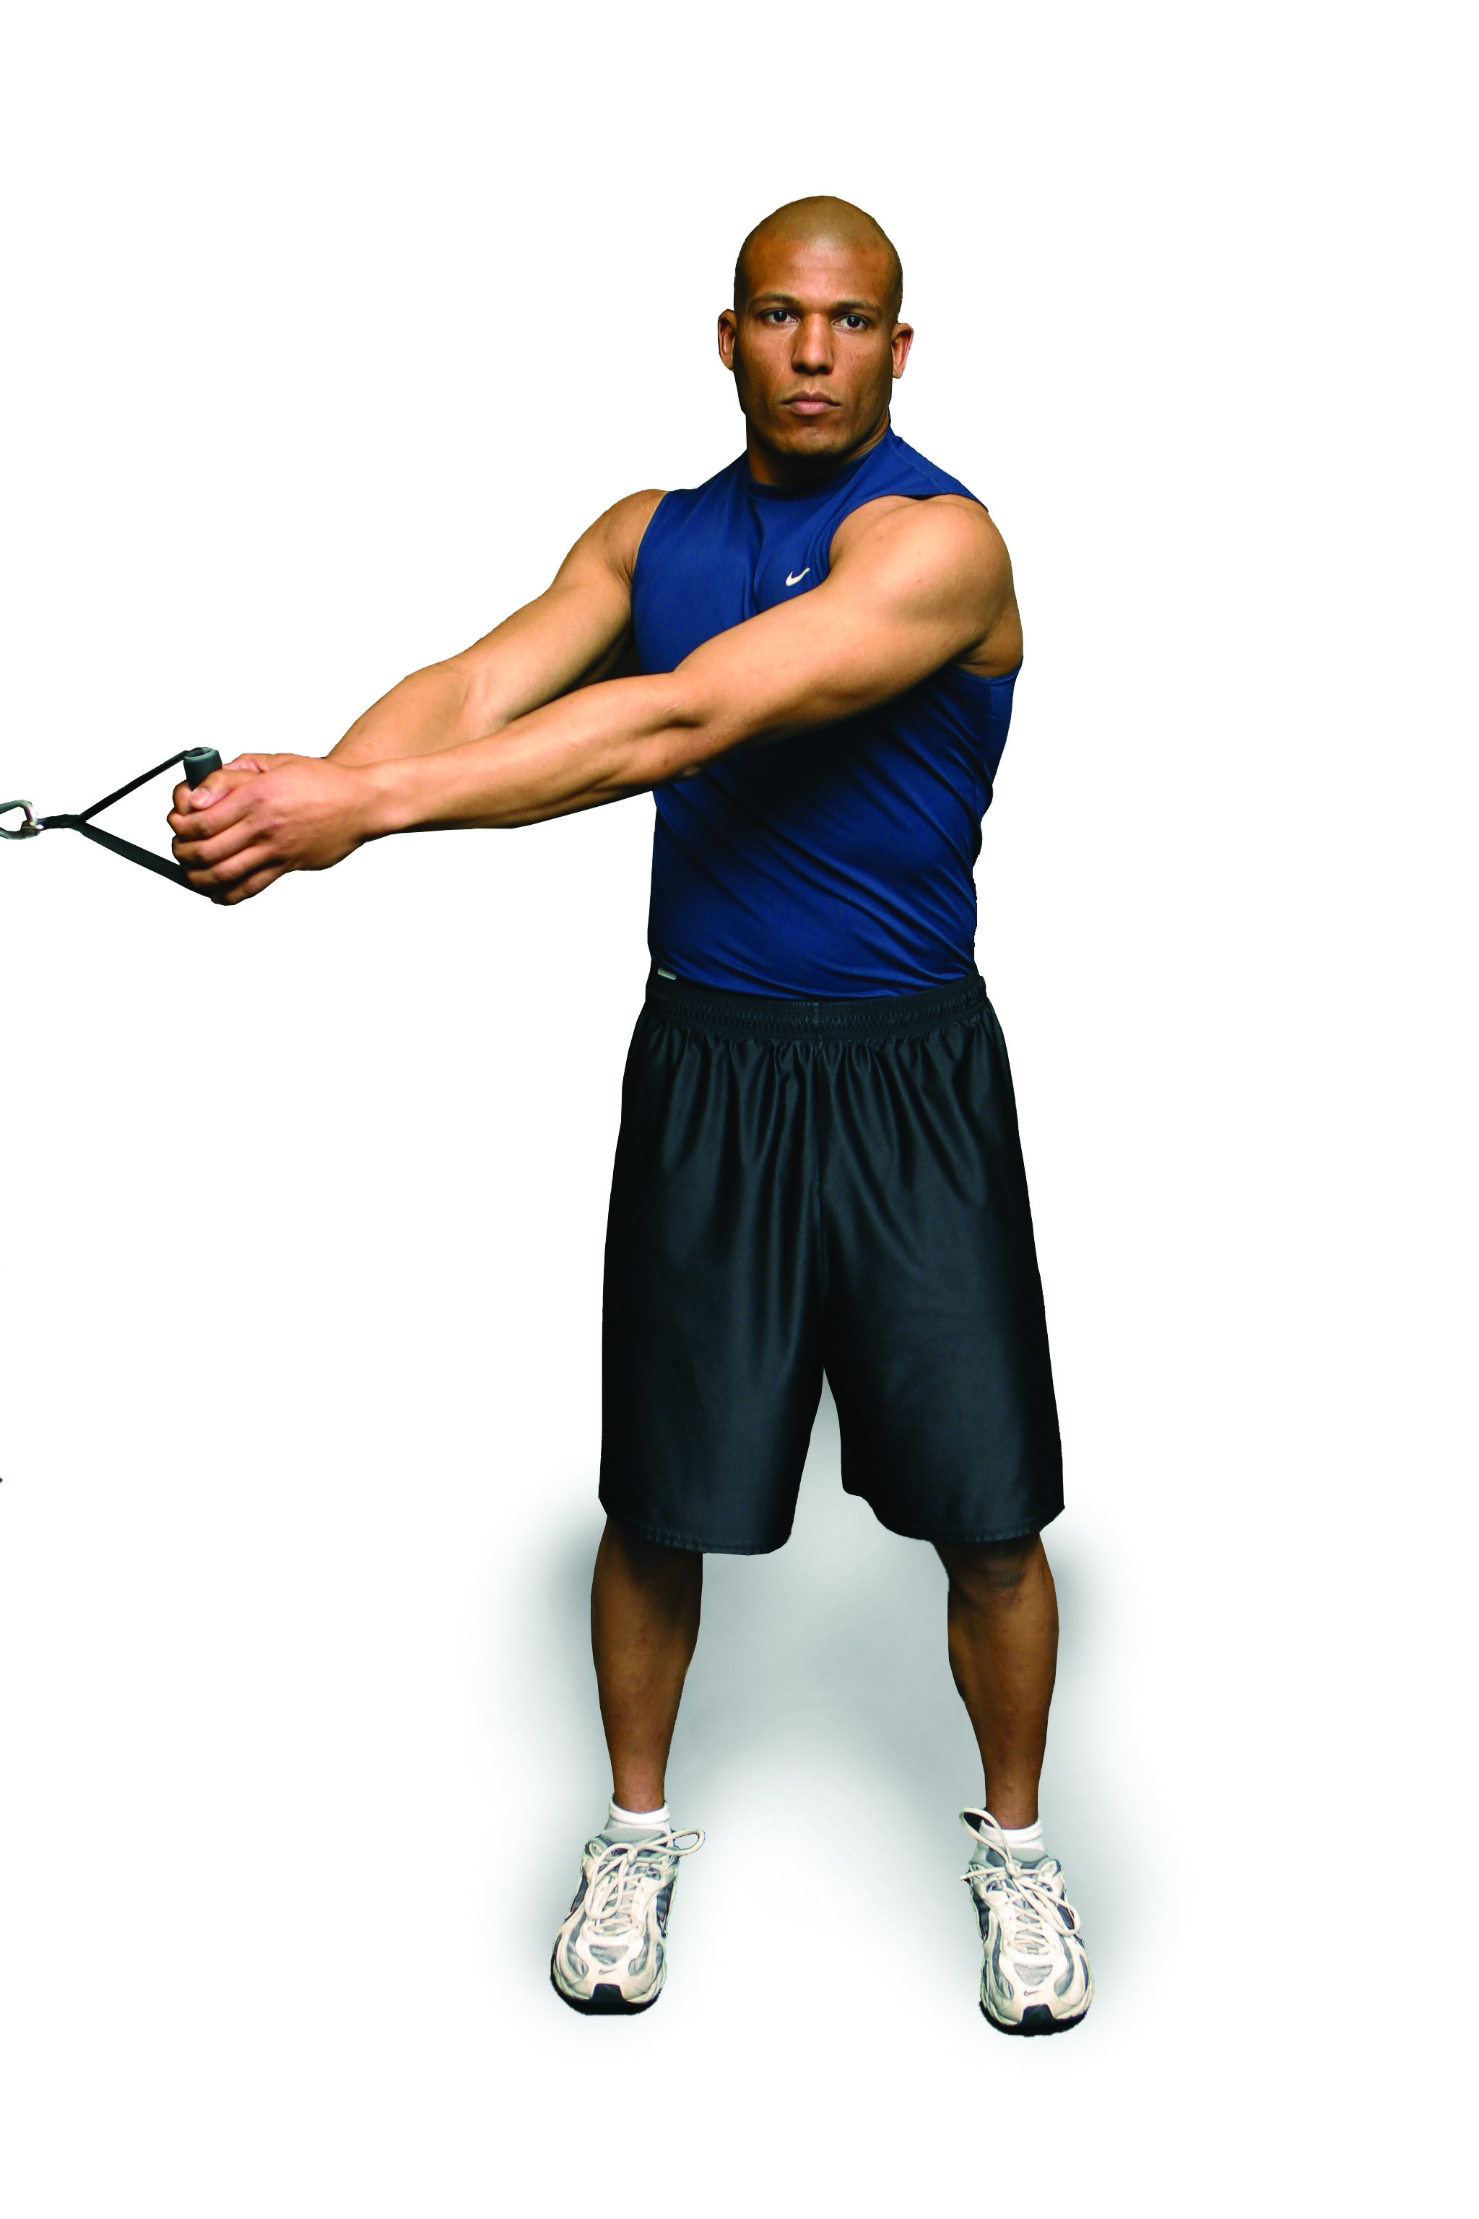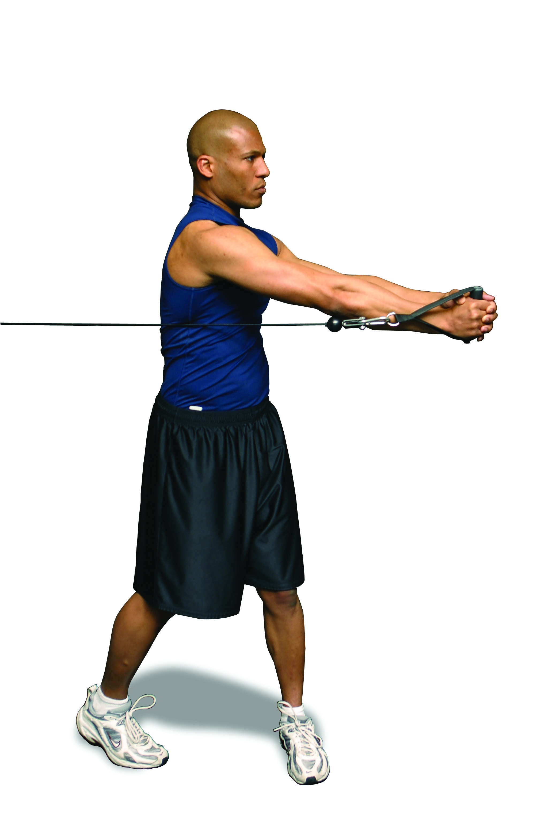 | Single-leg Squat  Progressions:  - Hands on hips  - Hands toward foot  - Eyes closed  - Add unstable surface  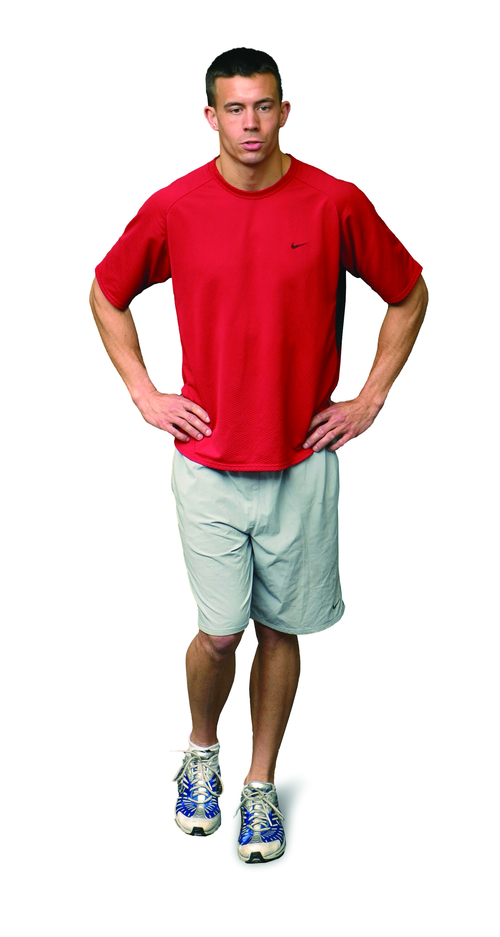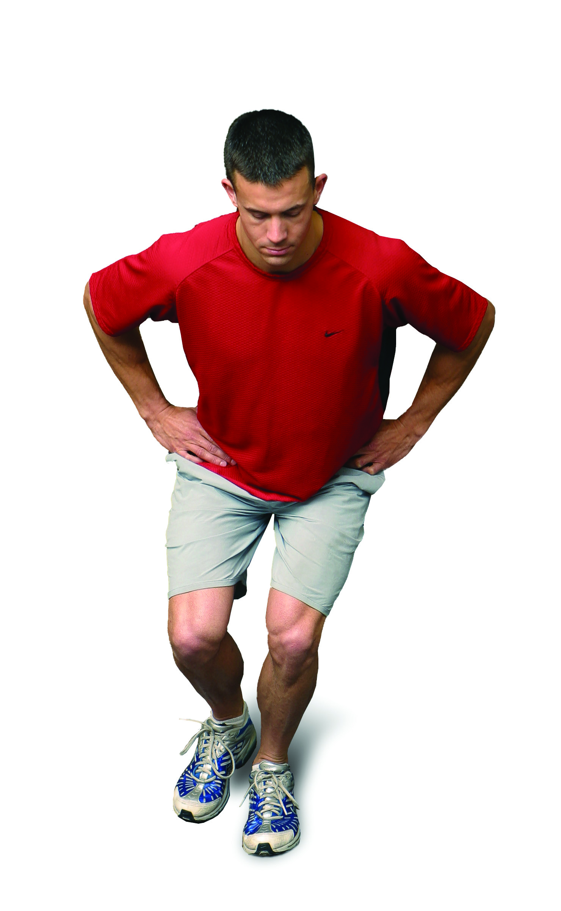 | Lunge to Balance  Progressions:  - Lunge to side  - Turning Lunge  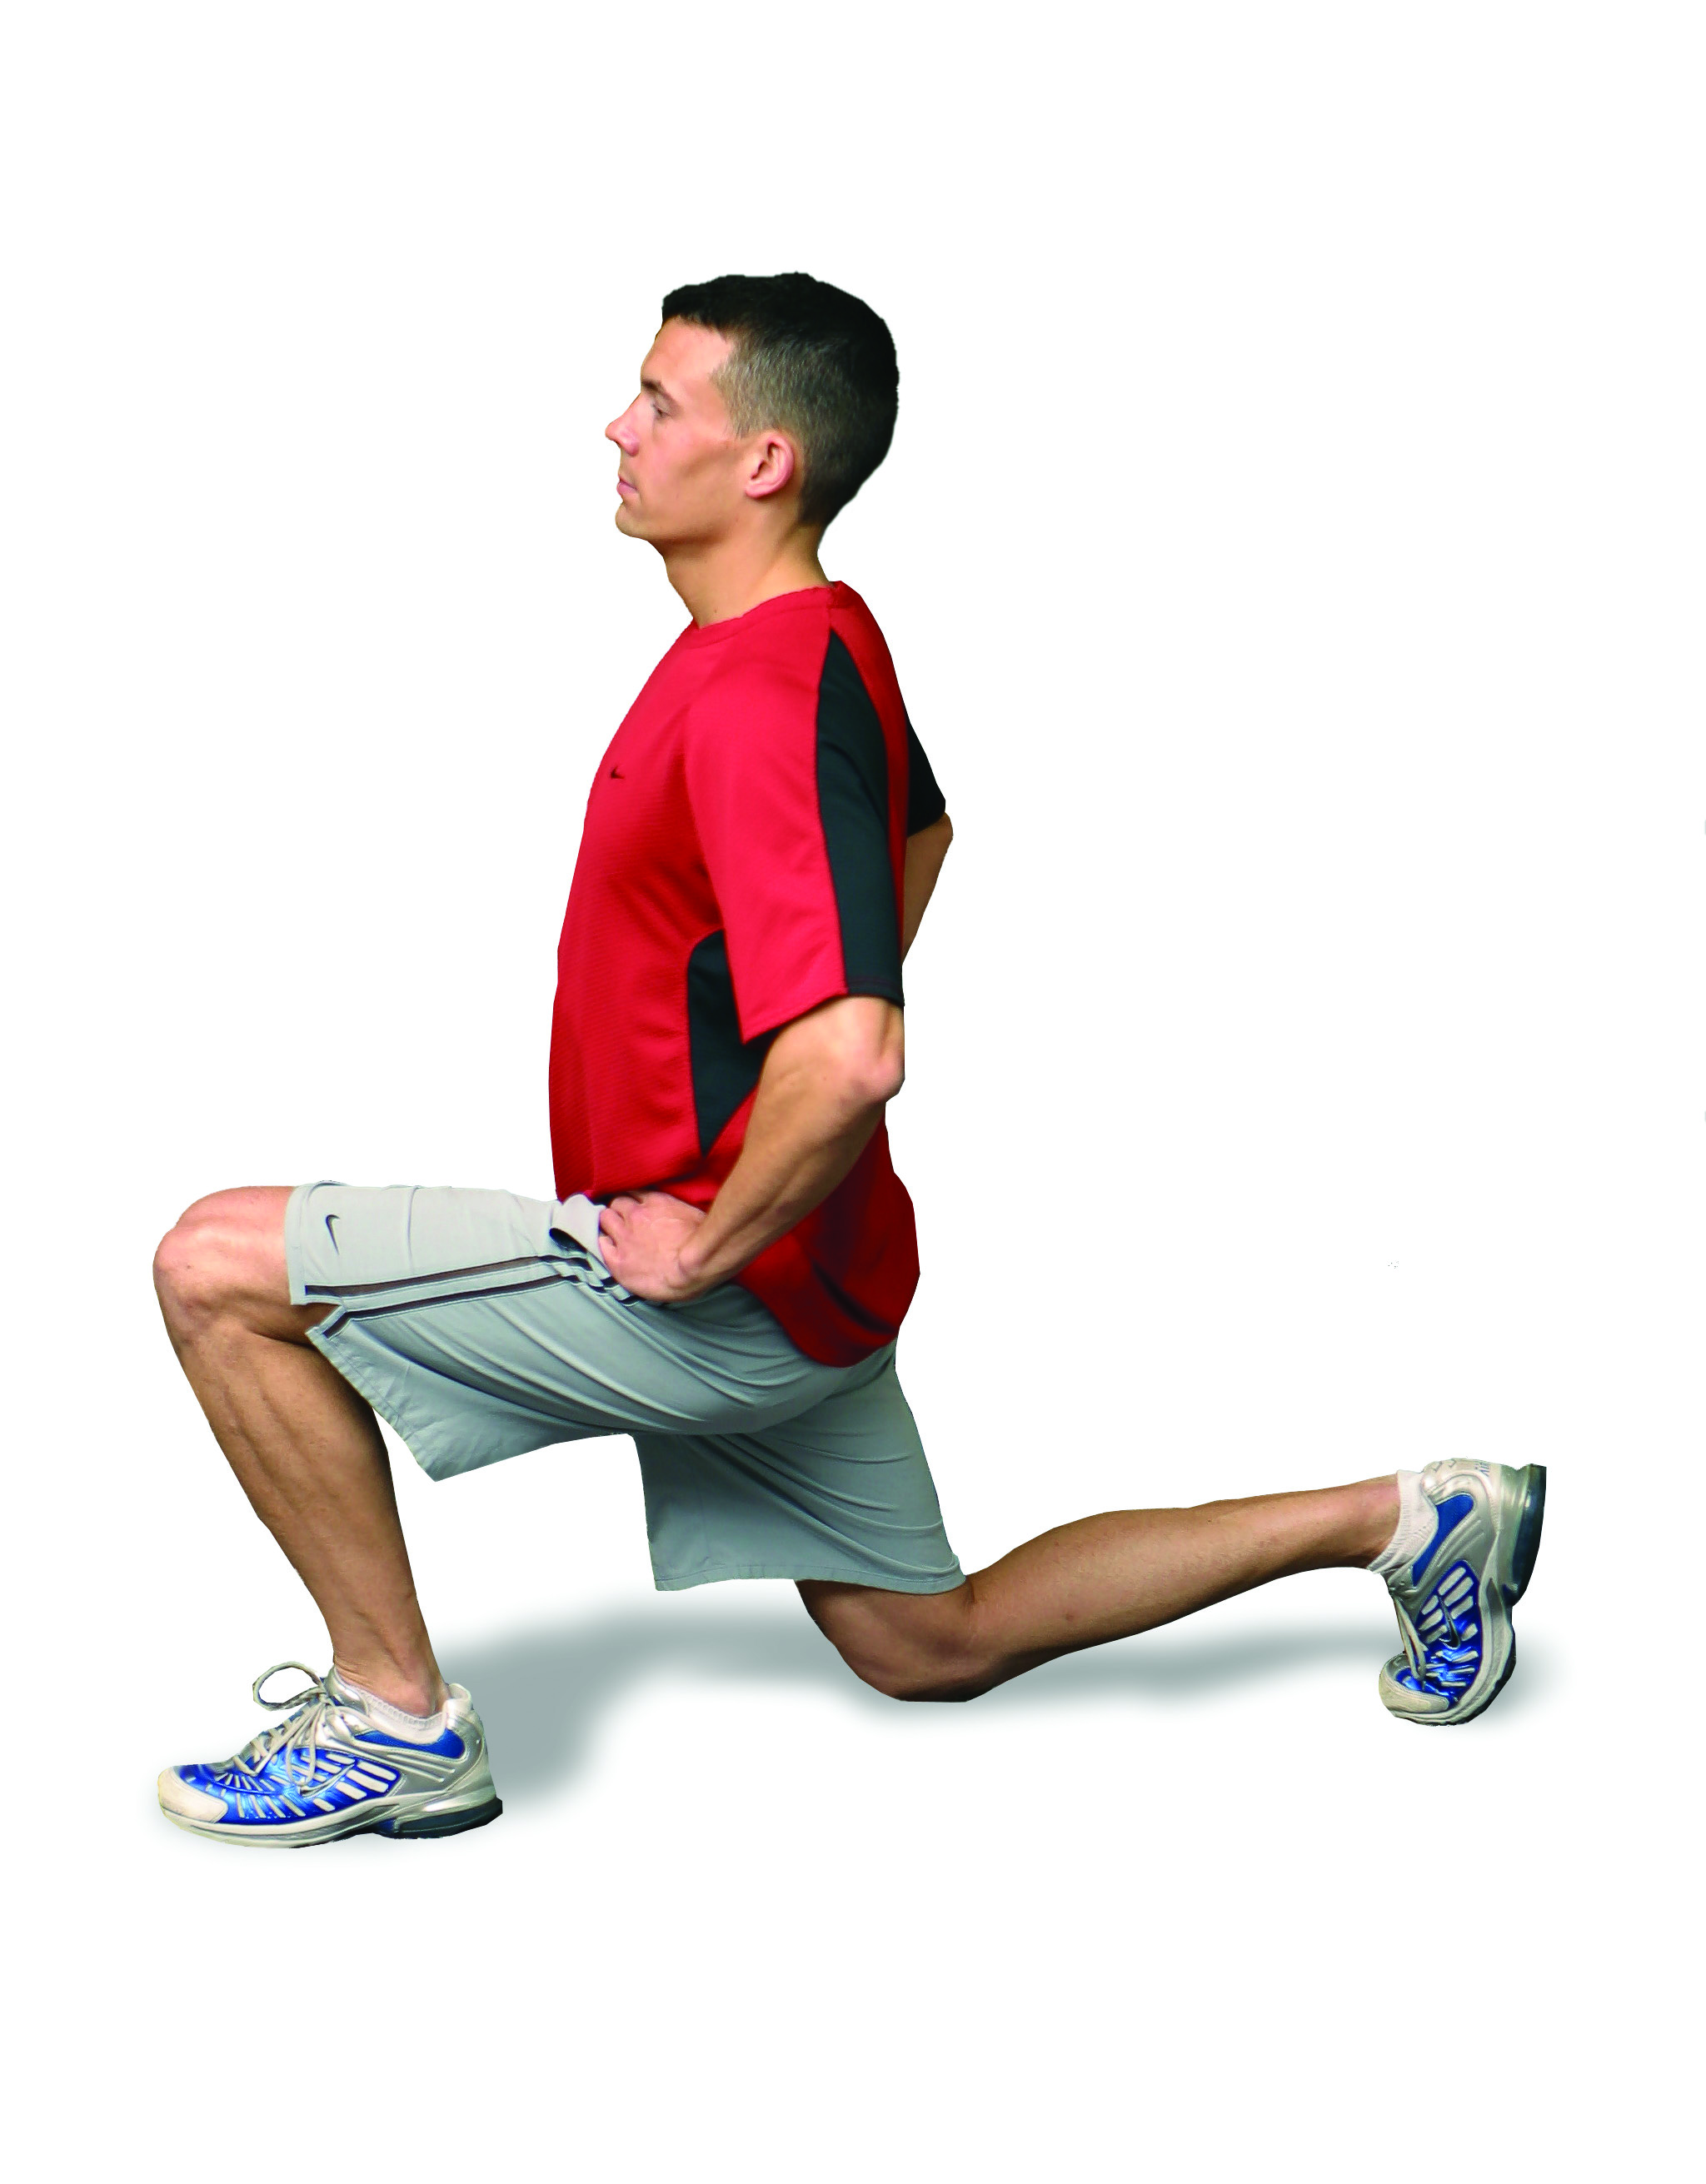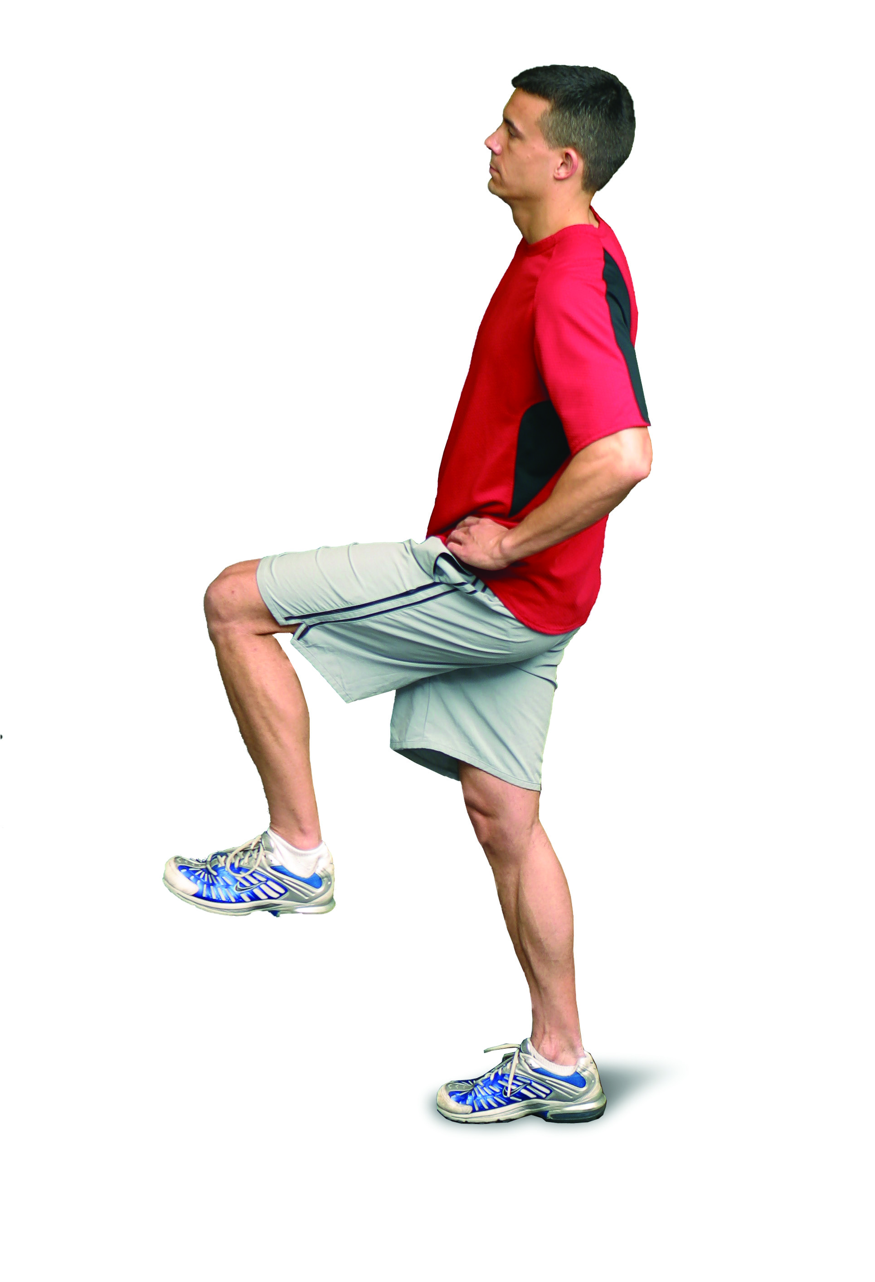

You can add small single-legged jumps to challenge your stabilization and balance….but please progress slowly to this option so you avoid injury.

